Al-Malik Al-Masiah Trading & Contracting L.L.C
Construction of Commercial & Residential Buildings, Roads
Power & Desalination Plants, Oil & Gas (Refinery & Gas Plants), Water Pipe Line and industries Projects
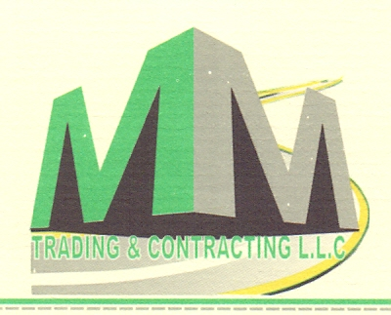
Supply of Heavy Equipment & Backfilling

P.O Box 869 Postal Code 512
Al-Buraimi
Sultanate of Oman
malik.sgb@mail.com
www.malikmc.com
+968-93377626 Oman

SULTANATE OF OMAN

COMPANY PROFILE

Al-Malik Al-Masiah Trading & Contracting L.L.C

Company Profile

Al-Malik Al Masiah (MMC) was established as a Grade-Excellent Civil Contracting Company in 2010.MMC

Establishing itself to be best-preferred partner for development in Oman. Company has more than 51 labors and 43 heavy machineries & vehicles.

Company principal activities are to construct industrial, commercial & residential building, Structural Steel Buildings, power plants, Refinery project, Sheds and roads (Earth work, Underpasses & Box culverts, Rip rap, Curbstones and Interlock)works. Al-Malik Al-Masiah has a highly Concern for Quality and Safety and till there was no injury on site.

List of Equipment

- JCB 3CX : 01 nos
- Dump Trucks : 04 nos
- Wheel loader : 01 nos
- Boom Loader : 01 nos
- Excavator : 01 nos
- Pick up : 03 nos
- Cars : 06 nos

Al-Malik Al-Masiah Trading & Contracting L.L.C

Organization Chart

Project Manager
Malik Shaukat

Site Surveyor
Asim Khan

Site Supervisor
Mohammad hanif

Accountant
Ms. Jinu
Project Engineer
Mohammad Sarim

Construction Manager
Malik Azam

QHSE Engineer
Shahab Khalil

Account Manager
To be nominated

QHSE Manager
Ahmed Alajmi

Operation Manager
Mubashir Bashir
HR & Admin Manager
Imad Al-maskari
Commercial Manager
Ammar Sultan

Al-Malik Al-Masiah Trading & Contracting L.L.C
List of Our Main Client Since 2010
- China Geo Engineering Reinforcement of Sharqiyah Water Transmission System (NAMA)
      - Start date: June 2024 End Date: Running Project Value: 95K OMR

- Arabian Industries ( Marmul Falcon ) 02GABION PROTECTION OF LIGHT POLES MABROOK (PDO)
      - Start date: Aug 2023 End Date: Oct 2024 Project Value: 45K OMR

- Anwar Fahud OQ ONCE OFF Procurement for Supply Services (OQ)
      - Start date: Sep 2023 End Date: Dec 2023 Project Value: 50K OMR

- Sohar Aluminum CONSTRUCTION OF BREAST CANCER UNIT IBRI HOSPITAL (MOH)
      - Start date: Aug 2023 End Date: Feb-2024 Project Value: 85K OMR

- Schlumberger ( Majees ) BISAT SHUAIBA PROJECT ( B-STATION) PF -0002 (OQ)
      - Start date: Nov 2022 End Date: Mar 2023 Project Value: 150K OMR

- China Geo Engineering Reinforcement of Sharqiyah Water Transmission System (DIAM)
      - Start date: Sep 2022 End Date: Oct 2023 Project Value: 400K OMR

- Anwar Fahud Projects LLC (Demolition & Installation of Gabion Boxes at 24” Gas Pipeline Salalah (OQ)
      - Start date: July 2022 End Date: Feb 2023 Project Value: 350K OMR

- TeQKnow Projects & GPS-OMAN (OGC/PDO- (OQ Gas Transportation Facilities/ Fahud Pig Launcher 32” (OQ)
      - Start date: July 2021 End Date: July 2022 Project Value: 0.28 million OMR

- Colossal & L&T-Oman (PAEW/DAIM- (Dakhliya Water Transmission Project 29KM)
      - Start date: Apr 2021 End Date: Running Project Value: 0.78 million OMR

- Target Construction Company (PAEW/DAIM– (Construction of Water reservoir tank – Al Barka)
      - Start date: Feb 2020 End Date: Mar 2021 Project Value: 1.33 million OMR

- Sarooj Construction Company (Ministry of Defense – MOD (13 Km Boundary wall Const-) (MOD)
      - Start date: Oct 2019 End Date: Nov 2020 Project Value: 0.2 million OMR

- Al TASNIM Enterprises L.L.C (Construction of High rise building Ghala-)
      - Start date: Jan 2020 End Date: Aug 2020 Project Value: 0.2 million OMR

- Al-Hassan Hi-tech Services (PAEW-DAIM (Up-Grading of pumping station)
      - Start date: Nov 2019 End Date: Feb 2021 Project Value: 0.75 million OMR

- Punj Lloyd Limited Oman (ORPIC & OGC - (Oman Gas Company) Earthwork) (OQ)
      - Start date: Nov 2018 End Date: Jan 2020 Project Value: 0.8 million OMR

- Punj Lloyd Limited Oman (ORPIC & OGC- (Oman Gas Company) CWC Pipe coating 32" & 14") (OQ)
      - Start date: Dec 2018 End Date: Sep 2019 Project Value: 0.56 million OMR

- Al-Hassan Hi-Tech Services (Majis Common cooling water system)
      - Start date: Nov 2018 End Date: July 2019 Project Value: 0.35 million OMR

- Descon Engineering Oman (Construction of workshop Sohar Industrial phase VII)
      - Start date: Dec 2018 End Date: Mar 2019 Project Value: 0.5 million OMR

- SNCC-Saudi National Contracting Company (Misfa to Izki 400KV-55/2017) Elect-line transmission
      - Start date: Sep 2017 End Date: Nov 2018 Project Value: 1.2 million OMR

- Saif Salem Al Jabri Two Twin Villas (Sohar Tareef Two Twin Villas 260,261)
      - Start date: Nov 2017 End Date: July 2018 Project Value: 0.15 million OMR

- Saif Salem Al Jabri Three villas (Sohar Falaj Al Ouhi Three Villas 584)
      - Start date: Nov 2017 End Date: Sep 2018 Project Value: 0.12 million OMR

- MIH Group UAE (Aluminum Factory & Storage Yard Project)
      - Start date: June 2017 End Date: Aug 2018 Project Value: 0.75 million OMR

- Musbah International (Construction of Commercial Building Sohar Ouhi Sanaiya)
      - Start date: Mar 2017 End Date: Sep 2018 Project Value: 3.0 million OMR

- BEC-Bahwan Engineering Company L.L.C (Liwa Plastic Project)
      - Start date: July 2017 End Date: Jan 2018 Project Value: 69 Thousand OMR

- Al-Hassan Engineering (Liwa Plastic Project) SOHAR PORT
      - Start date: Dec 2016 End Date: April 2017 Project Value: 0.13 million OMR

- University of Buraimi (Food Oasis Building) UNIVERISTY OF BURAIMI
      - Start date: May 2015 End Date: July 2016 Project Value: 0.47 million OMR

- Larsen & Toubro (Oman) L.L.C (University of Buraimi)
      - Start date: April 2015 End Date: Oct 2015 Project Value: 50 Thousand OMR

- CCC (consolidated Contracting Co) & Apex (Sohar-Zurub Road)
      - Start date: Feb 2015 End Date: Mar 2016 Project Value: 0.32 million OMR

- Global Chemical & Maintenance L.L.C (Majan Sub-Station Nizwa Projects)
      - Start date: Nov 2015 End Date: July 2016 Project Value: 88.5 Thousand OMR

- Global Chemical & Maintenance L.L.C (STP/Royal Oman Police Aswad Project)
      - Start date: Nov 2015 End Date: July 2016 Project Value: 88.5 Thousand OMR

- Global Chemical & Maintenance L.L.C (STP/Royal Oman Police Hafeet Project)
      - Start date: Nov 2015 End Date: July 2016 Project Value: 88.5 Thousand OMR

- Muscat Projects & Environmental L.L.C (STP/Royal Oman Police Khatwa Project)
      - Start date: Dec 2015 End Date: Sep 2016 Project Value: 83.5 Thousand OMR

- Muscat Overseas L.L.C (20 class Room Boy School Khadra Buraimi Project)
      - Start date: May 2015 End Date: Aug 2016 Project Value: 72 Thousand OMR

- Yas Medical L.L.C (Yas Medical Complex Buraimi Project)
      - Start date: Dec 2015 End Date: Dec 2016 Project Value: 0.17 million OMR

- Union Engineering Consultancy (Private Commercial Buildings Mahdha)
      - Start date: Sep 2014 End Date: May 2015 Project Value: 0.10 million OMR

- Kingdom Middle East L.L.C (Sohar & Buraimi Aluminum Factories)
      - Start date: Mar 2014 End Date: Jan 2015 Project Value: 0.11 million OMR

- Al-Ansari Contracting L.L.C (Qaboos Mosque Mahdha Project)
      - Start date: June 2014 End Date: Jan 2015 Project Value: 48 Thousand OMR

- Dawood Contracting Company (Vocational School Buraimi Project)
      - Start date: Nov 2013 End Date: Aug 2014 Project Value: 66 Thousand OMR

- Hassan Juma Baker – Assignia (Sohar Port Extension Project)
      - Start date: June 2013 End Date: Dec 2013 Project Value: 2.6 million OMR

- Amjaad Modern Projects Co. L.L.C (Meethaq / Muscat Islamic Bank Buraimi)
      - Start date: Nov 2012 End Date: Feb 2013 Project Value: 90 Thousand OMR

Al-Malik Al-Masiah Trading & Contracting L.L.C
Logo of Our Main Client Since 2010
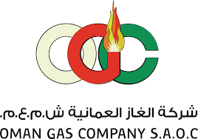
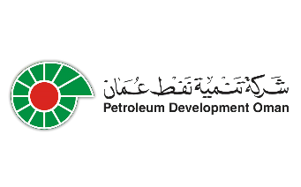







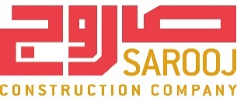
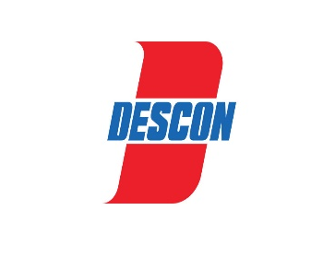
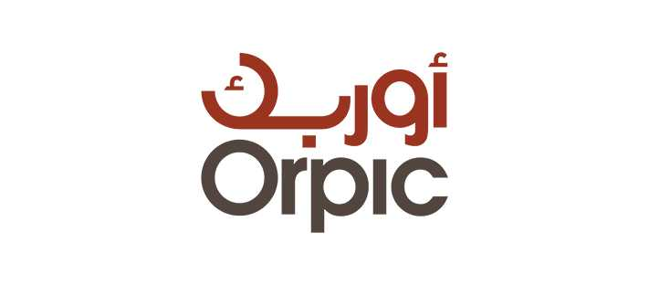
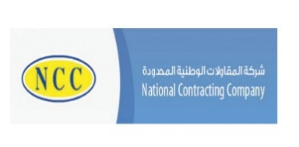
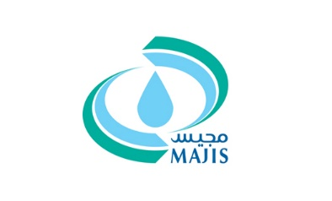

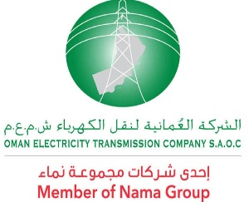
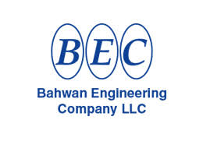
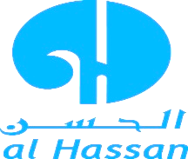



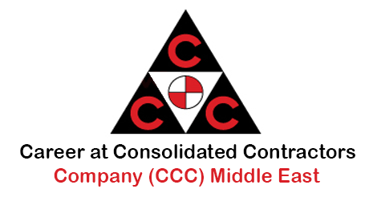



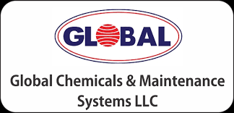
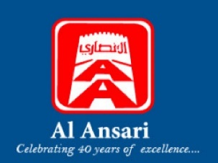
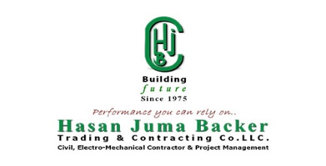
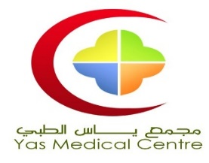
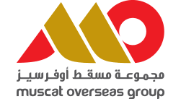

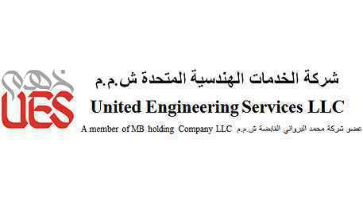


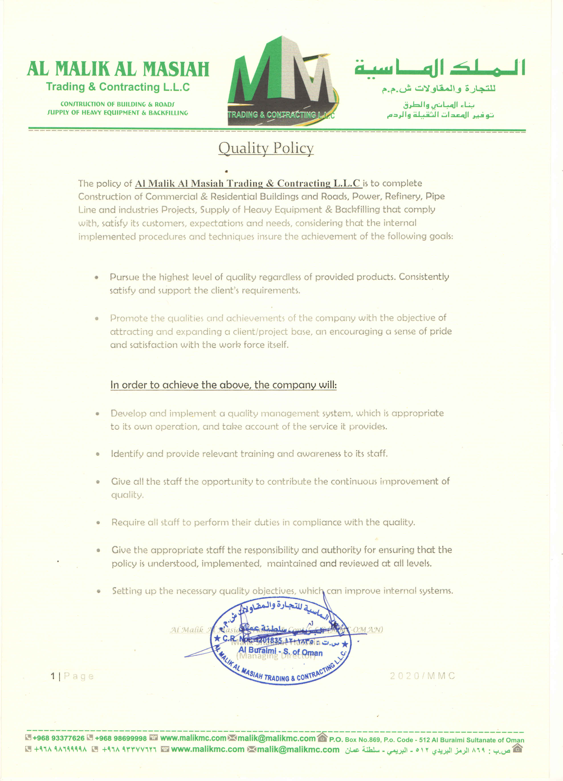

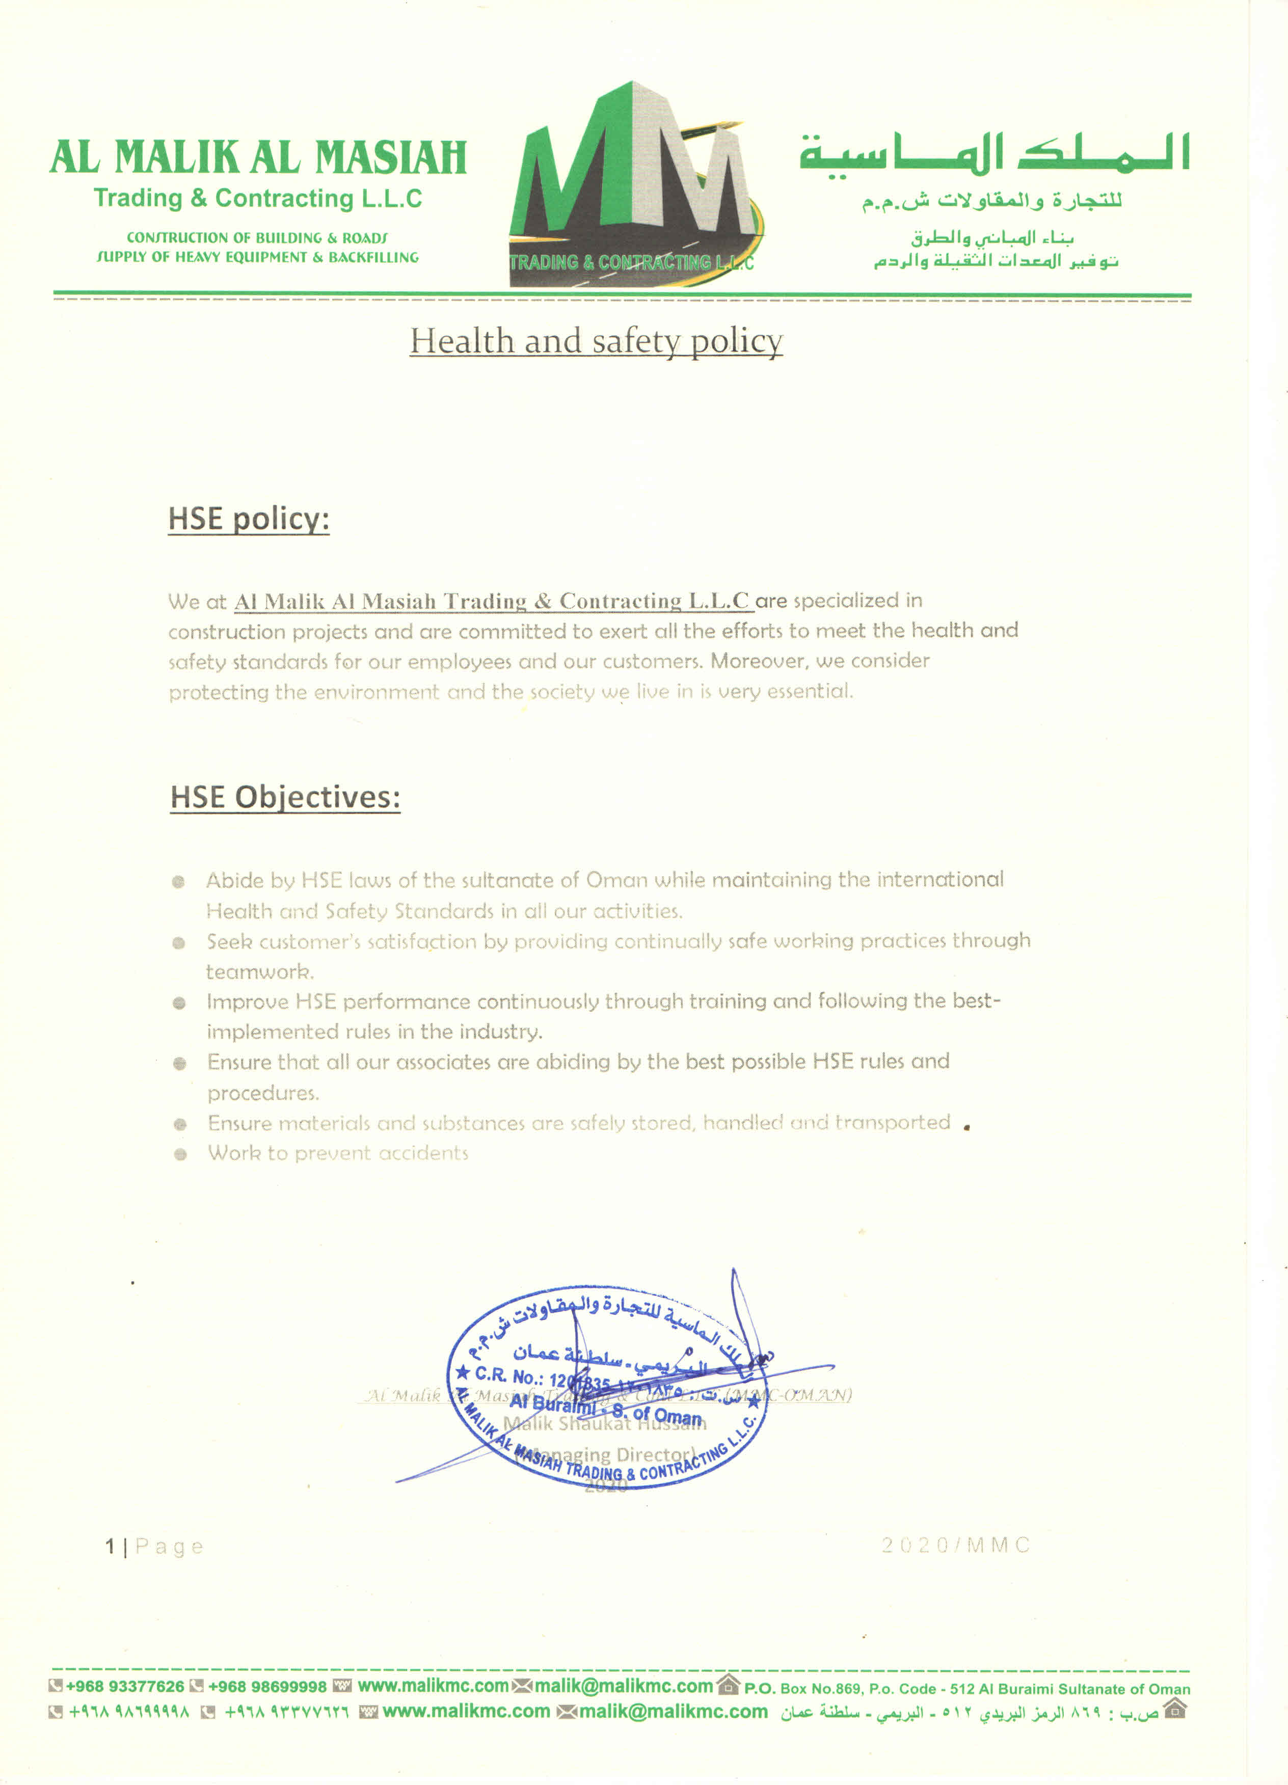

Al-Malik Al-Masiah Trading & Contracting L.L.C
Reinforcement of Al-Sharqiyah Water Transmission System
Sharqiyah – Oman Road Work

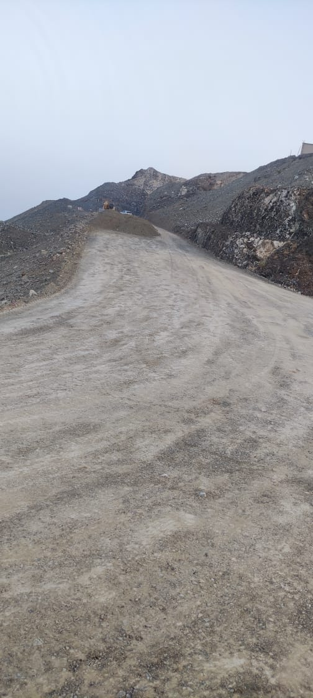
Al-Malik Al-Masiah Trading & Contracting L.L.C
Protection of Light Poles Mabrook (PDO)
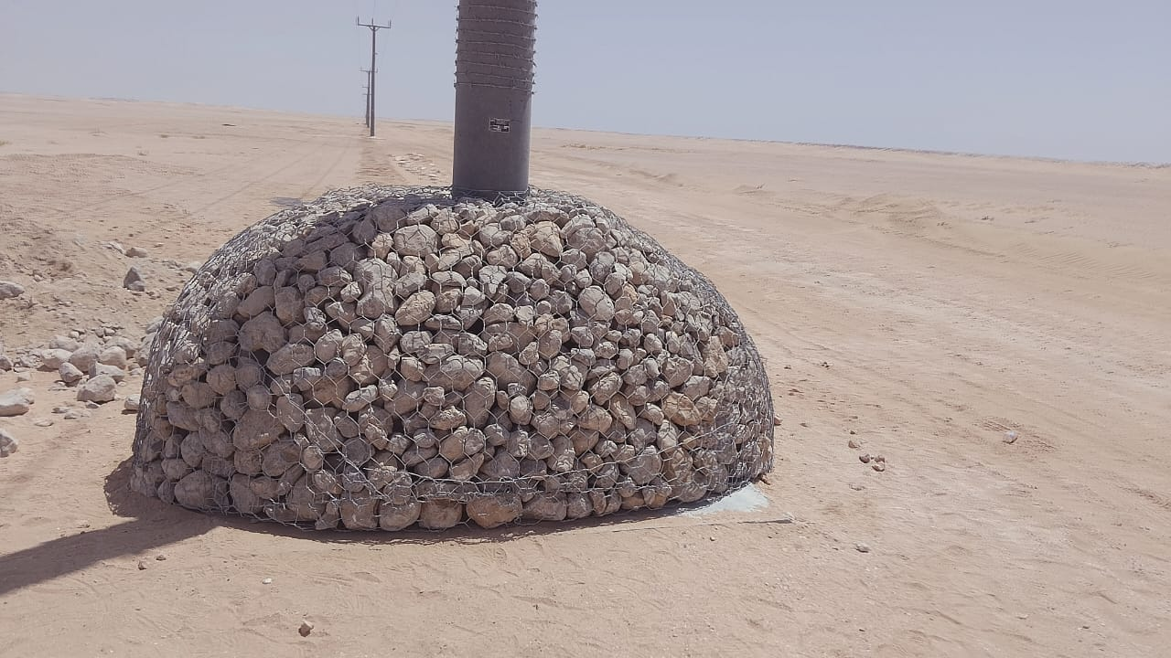
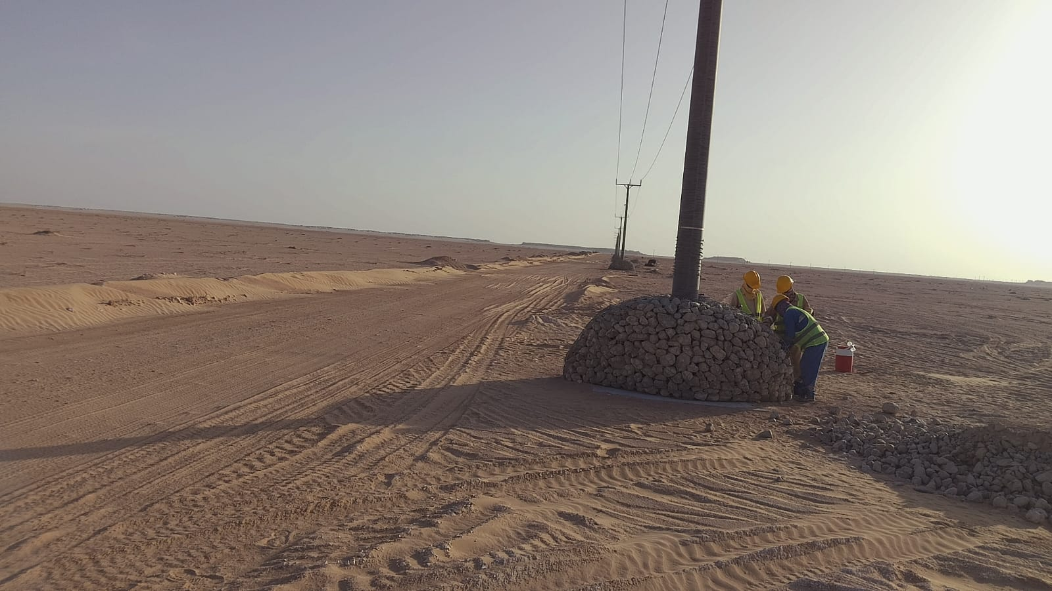
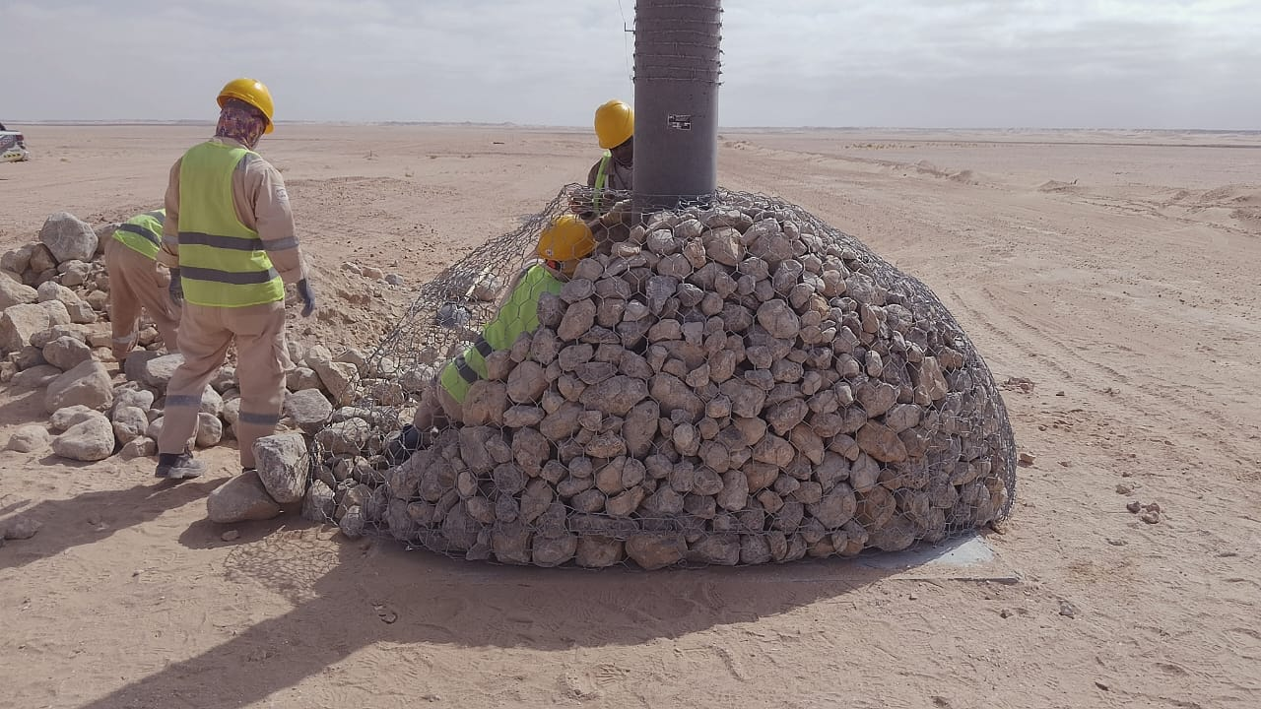
Al-Malik Al-Masiah Trading & Contracting L.L.C
OQ ONCE OFF Procurement for Supply Services (OQ)

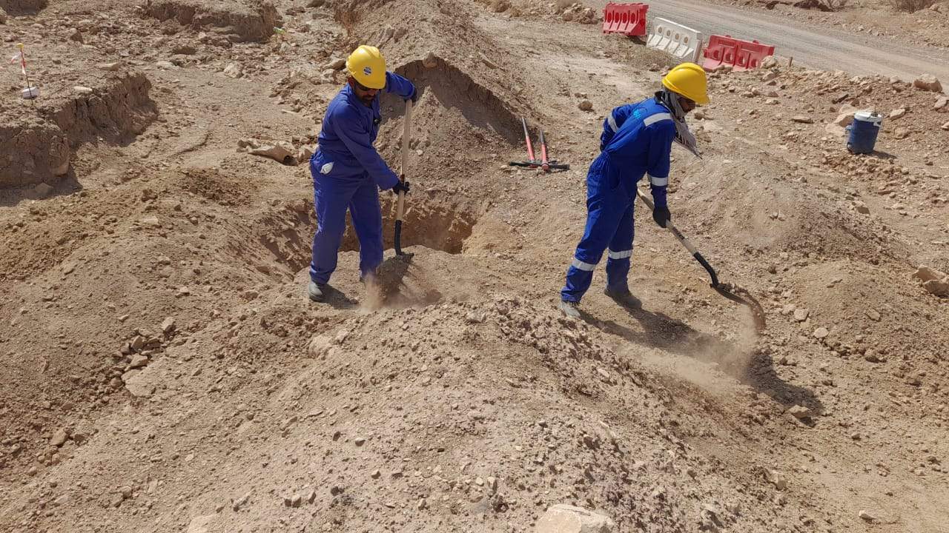

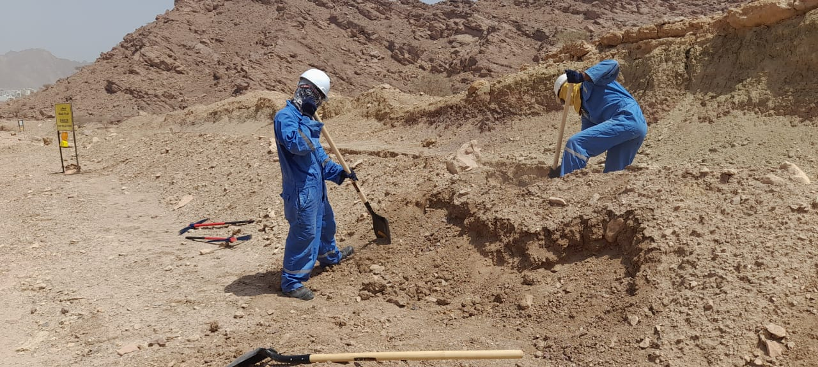
Al-Malik Al-Masiah Trading & Contracting L.L.C
Construction of Breast Cancer Unit IBRI Hospital (MOH)

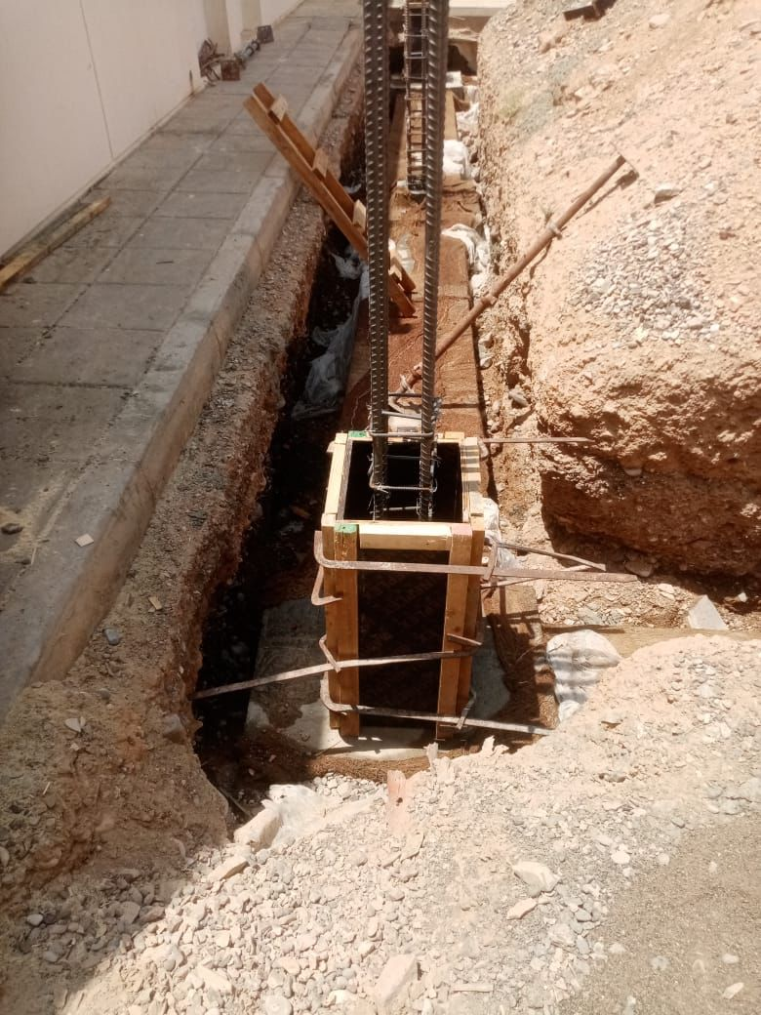
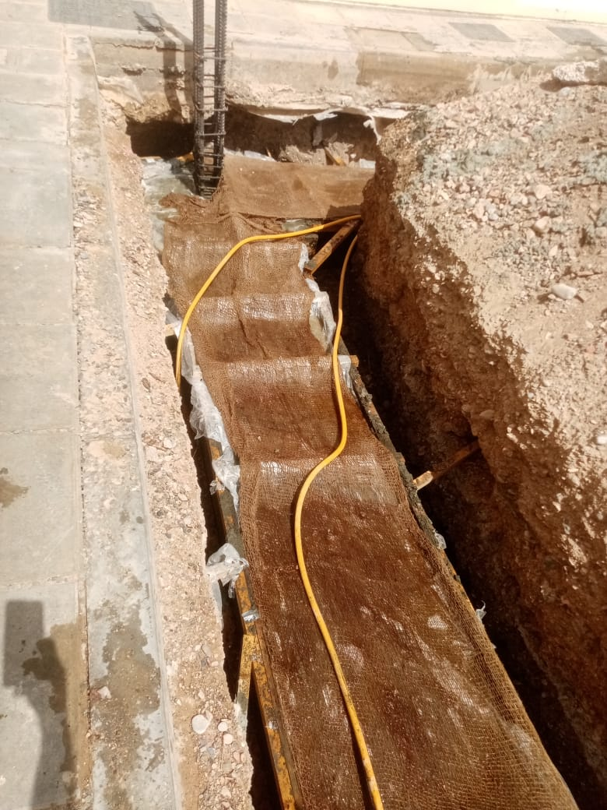

Al-Malik Al-Masiah Trading & Contracting L.L.C
Bisat Shuaiba Project (B-Station ) PF-0002(OQ)

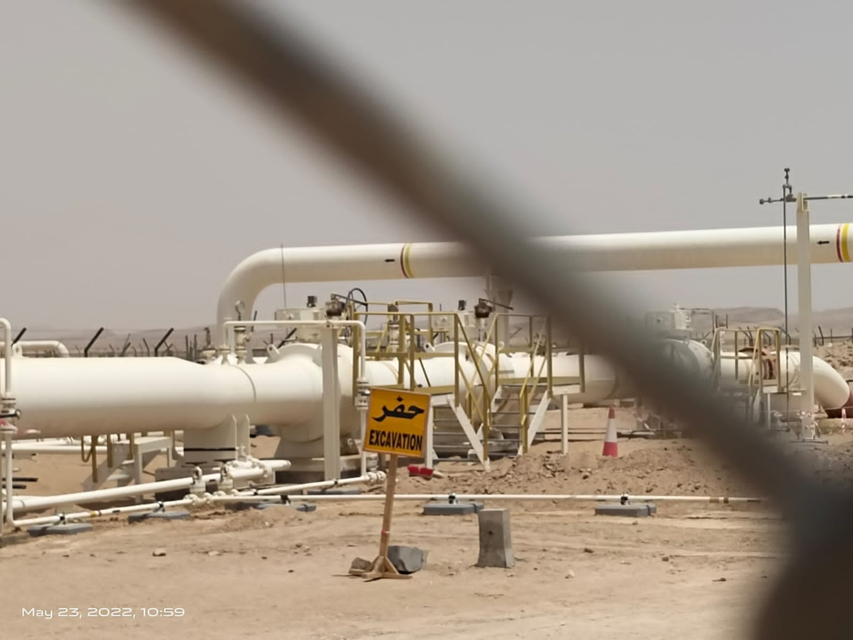

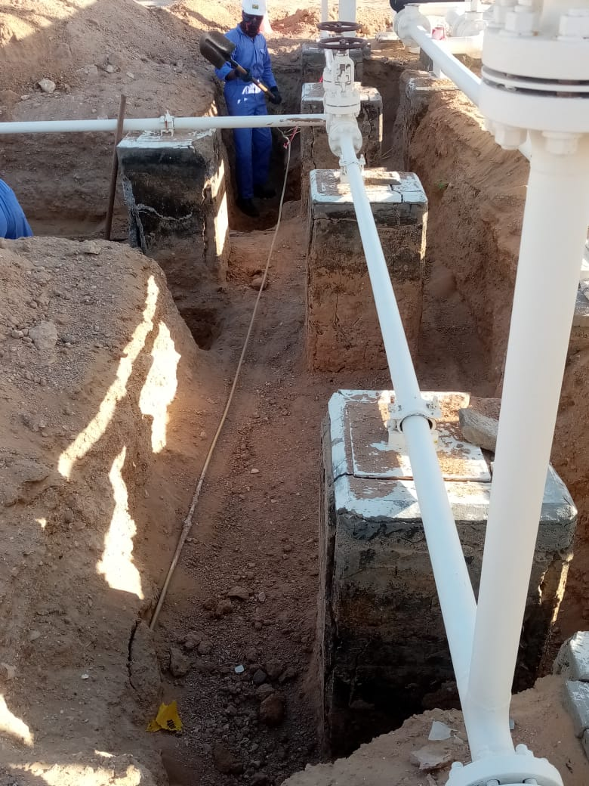

Al-Malik Al-Masiah Trading & Contracting L.L.C
Reinforcement of Al-Sharqiyah Water Transmission System
Sharqiyah - Oman
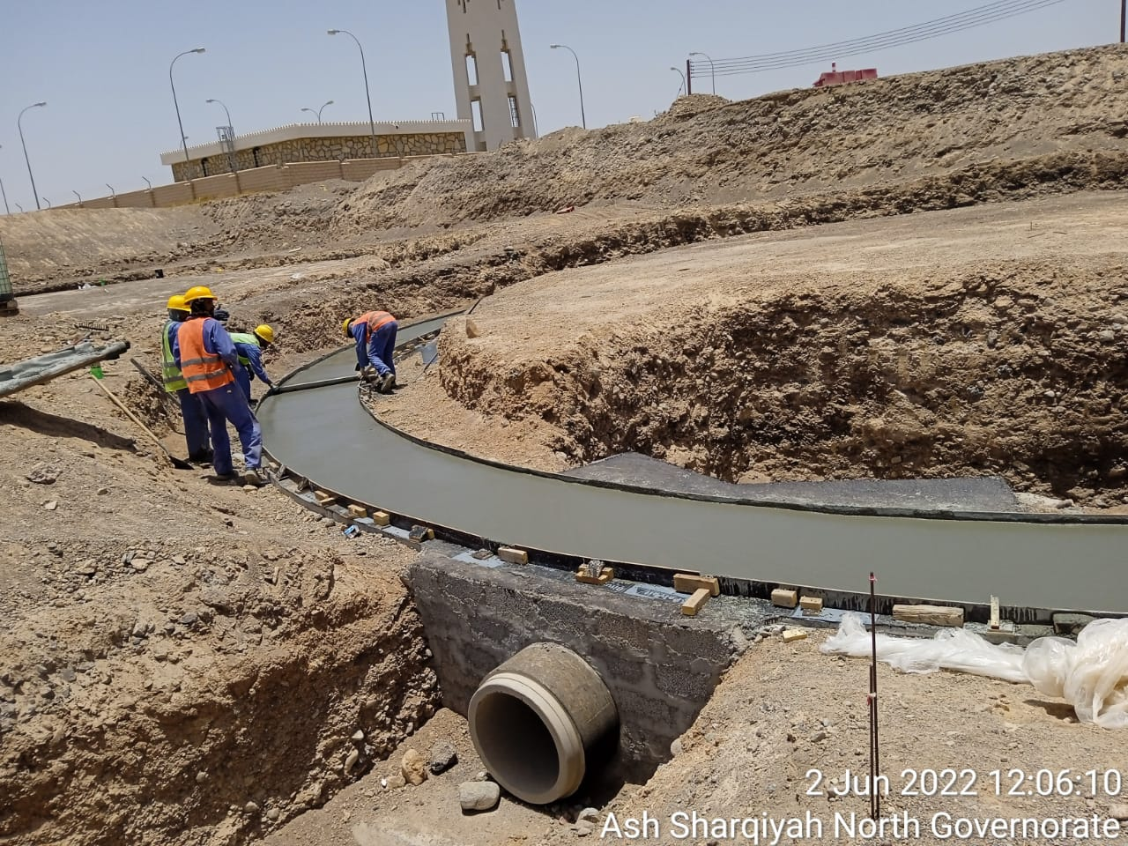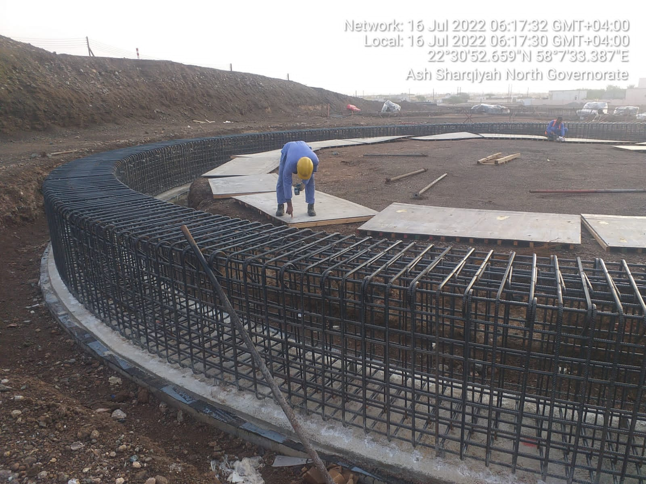

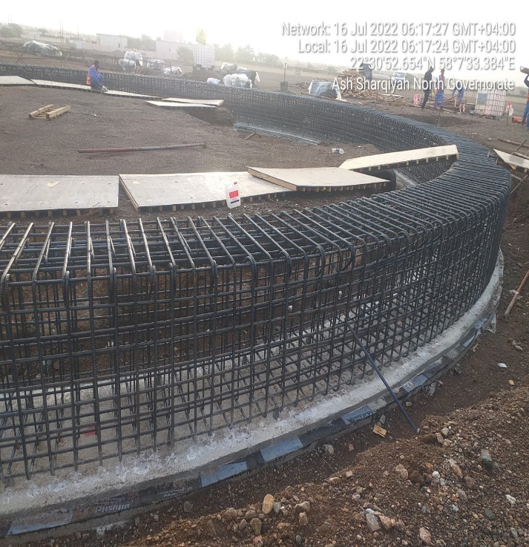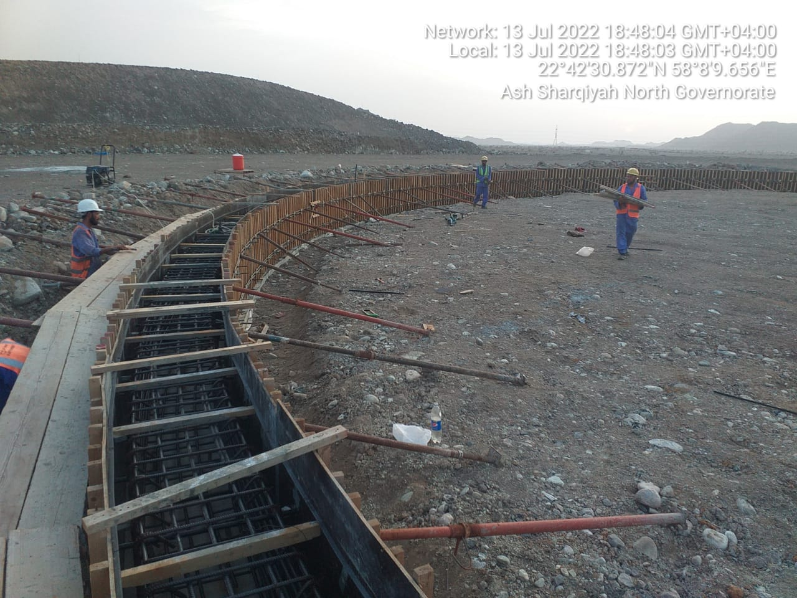
Al-Malik Al-Masiah Trading & Contracting L.L.C
Reinforcement of Al-Sharqiyah Water Transmission System
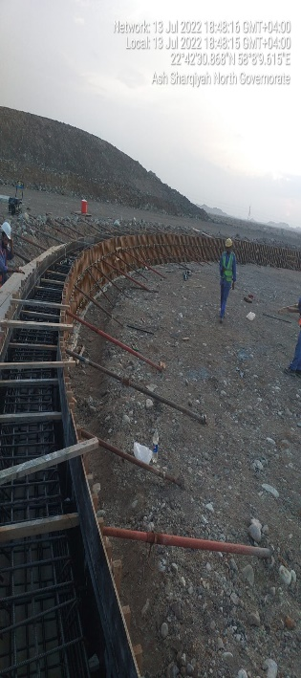
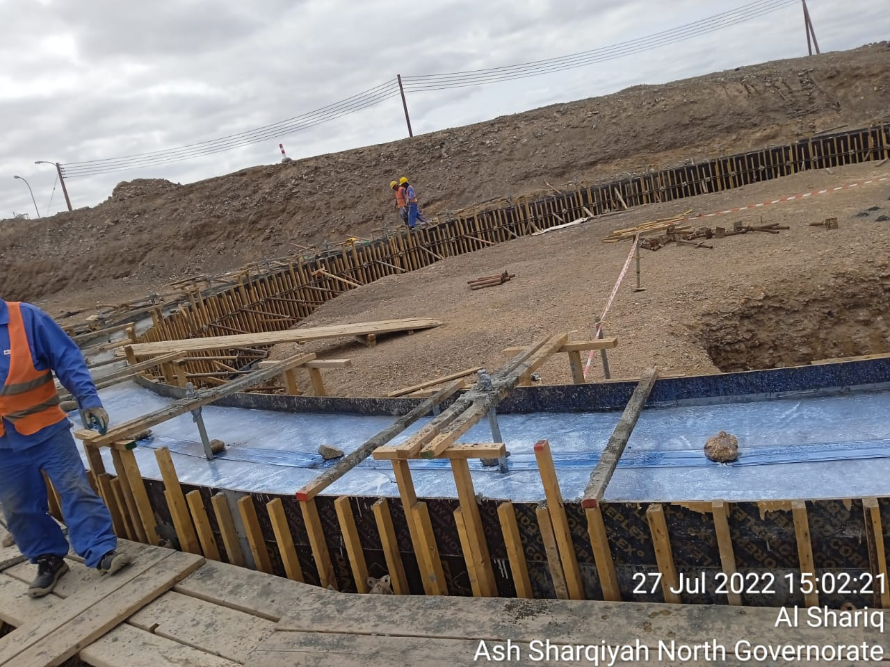
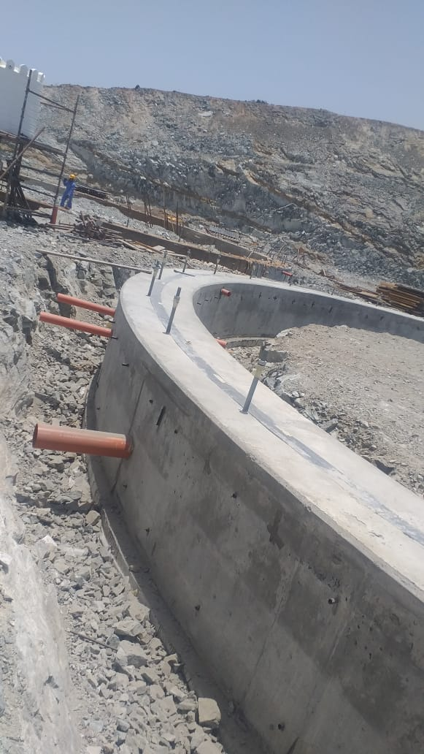
Al-Malik Al-Masiah Trading & Contracting L.L.C
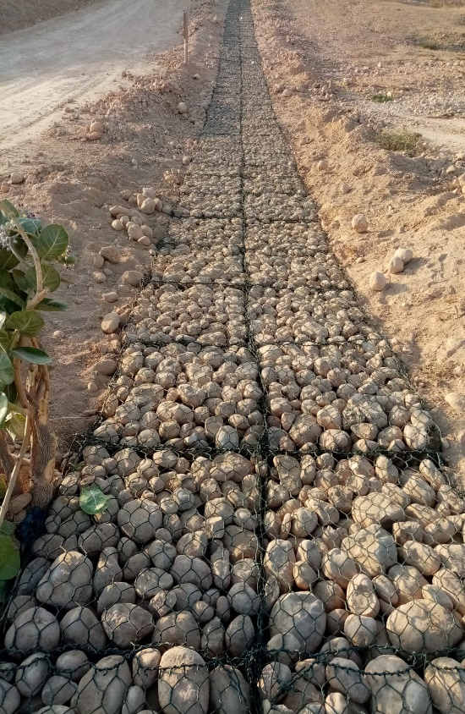
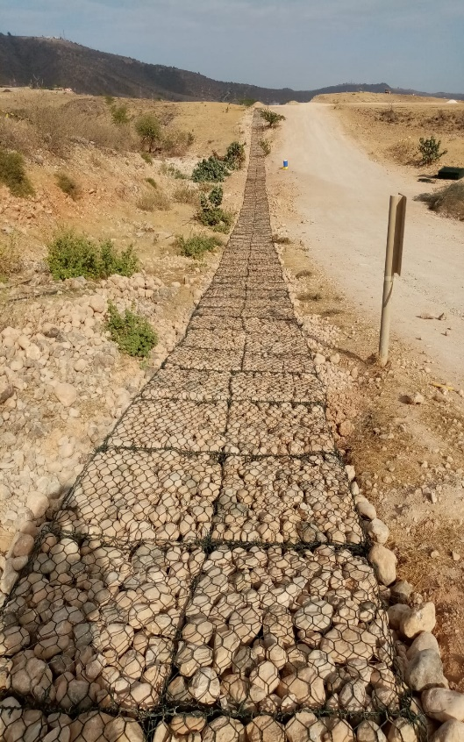
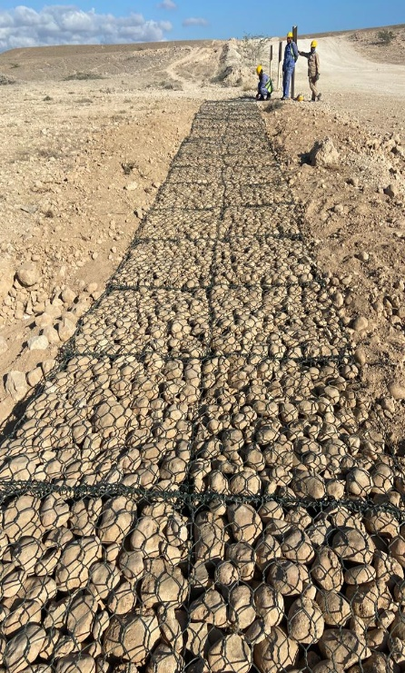
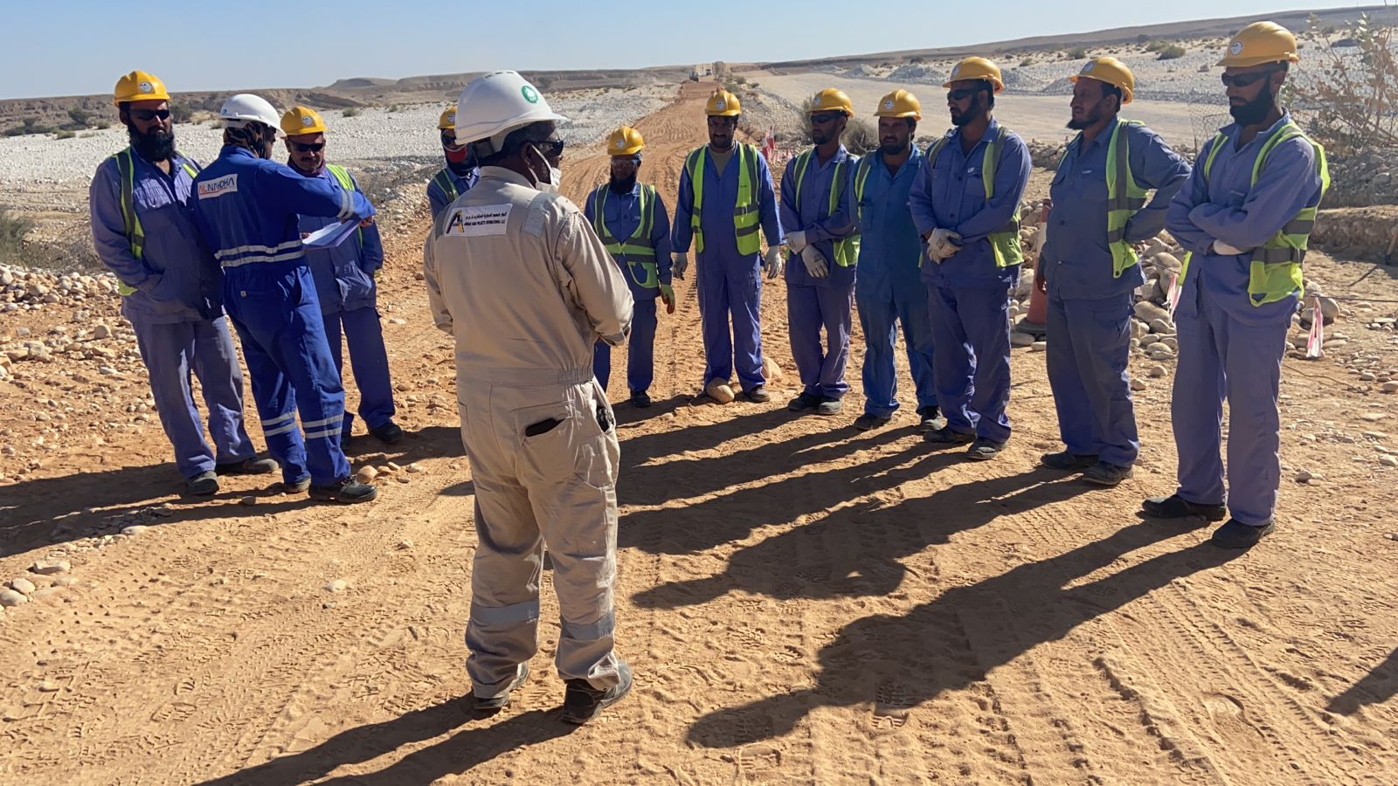
Demolition & Installation of Gabion at 24” Gas Pipeline Salalah (OQ)

Al-Malik Al-Masiah Trading & Contracting L.L.C
OGC (OQ) Gas Transmission Facilities in Fahud Gas Station (Underneath 32” & 14” Launcher live Gas lines F.C.S)

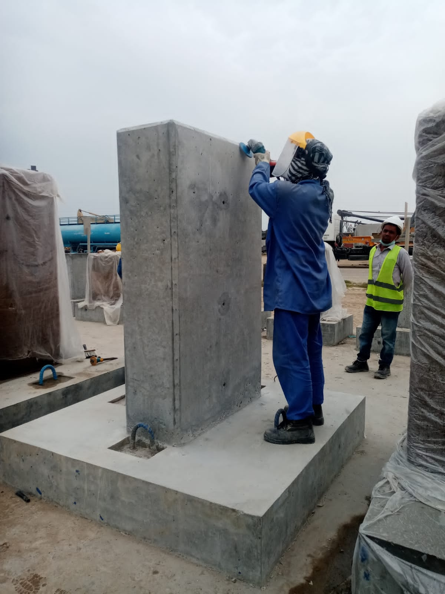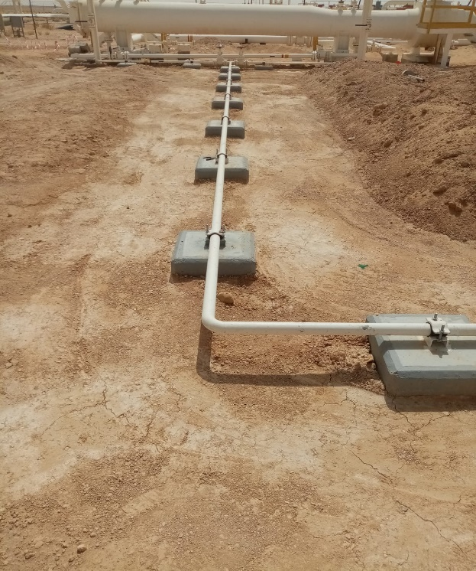
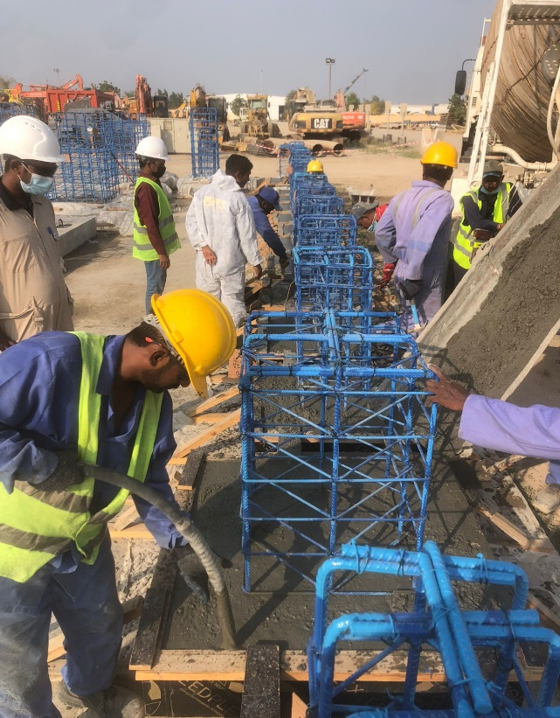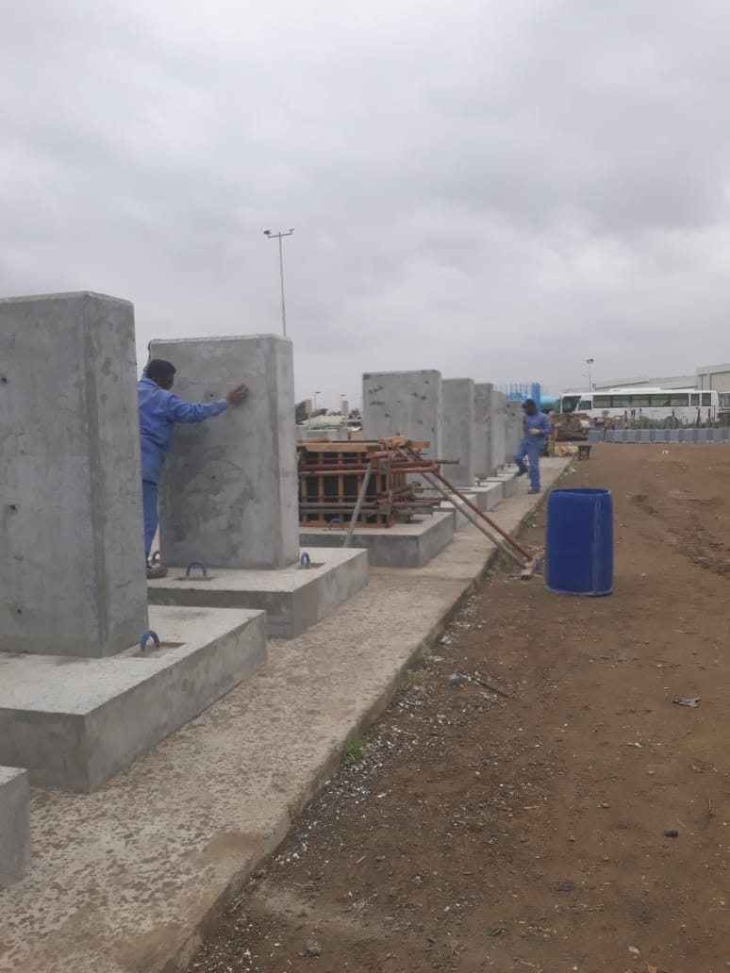
Al-Malik Al-Masiah Trading & Contracting L.L.C
Colossal- L&T –Dakhliya Water Transmission Project
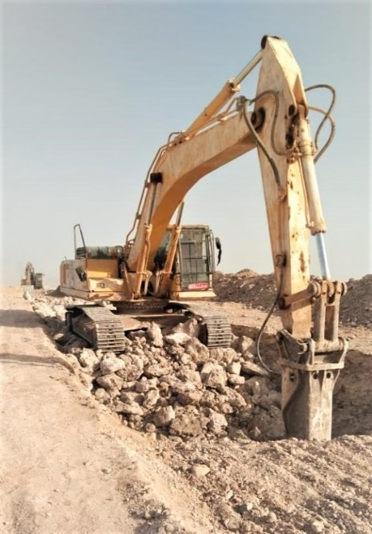
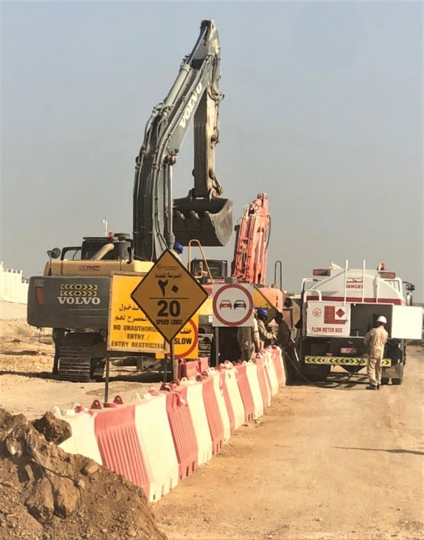
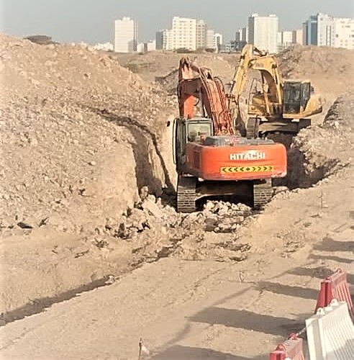

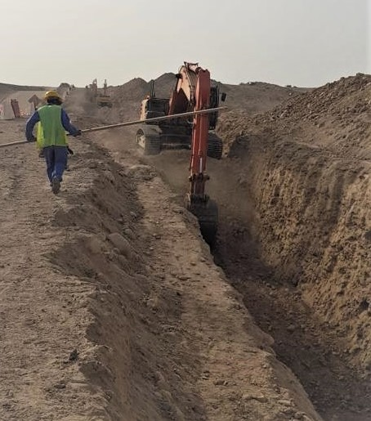
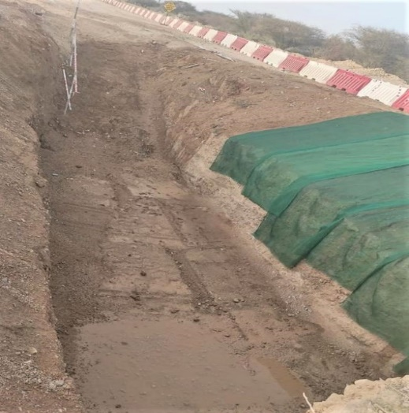
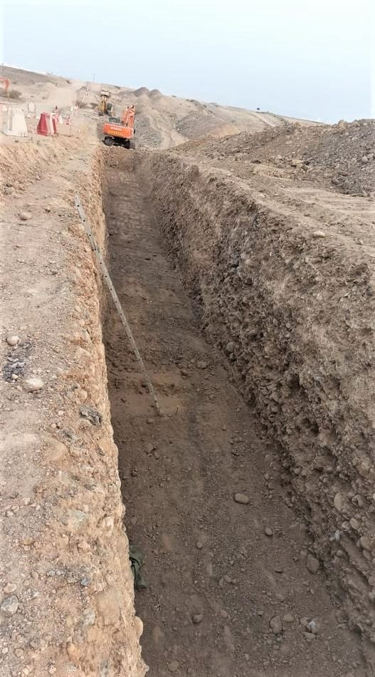

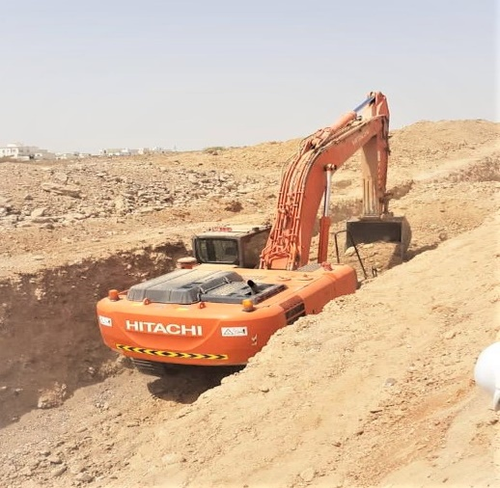

Al-Malik Al-Masiah Trading & Contracting L.L.C
Target Construction L.L.C –PAEW/DAIM (Water Reservoir Tank) BARKA - MUSCAT
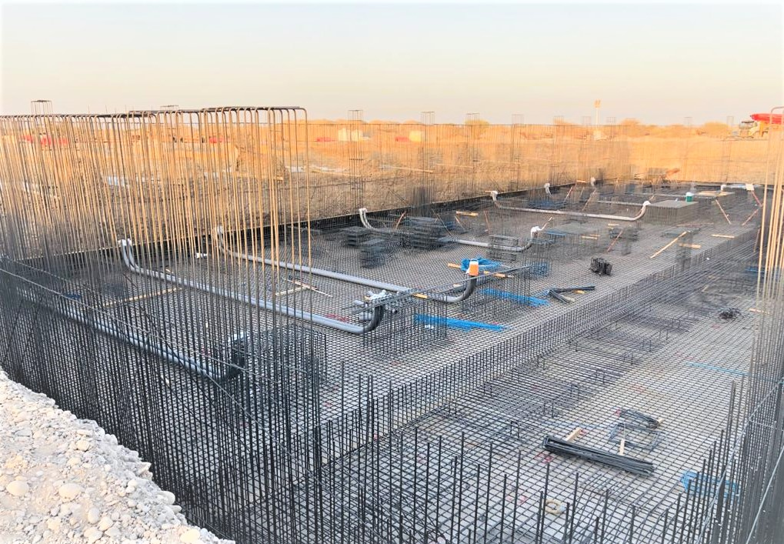

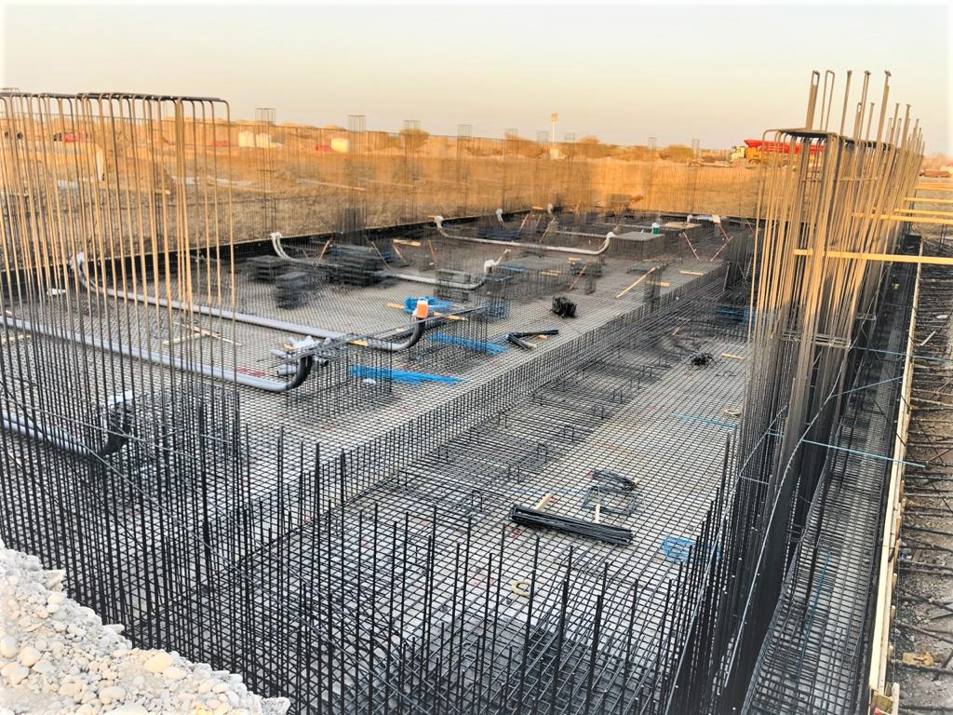

Al-Malik Al-Masiah Trading & Contracting L.L.C
Al-Sarooj Construction Company –Ministry Of Defense-MOD (13 km Boundary wall)
Thumraith-Salalah
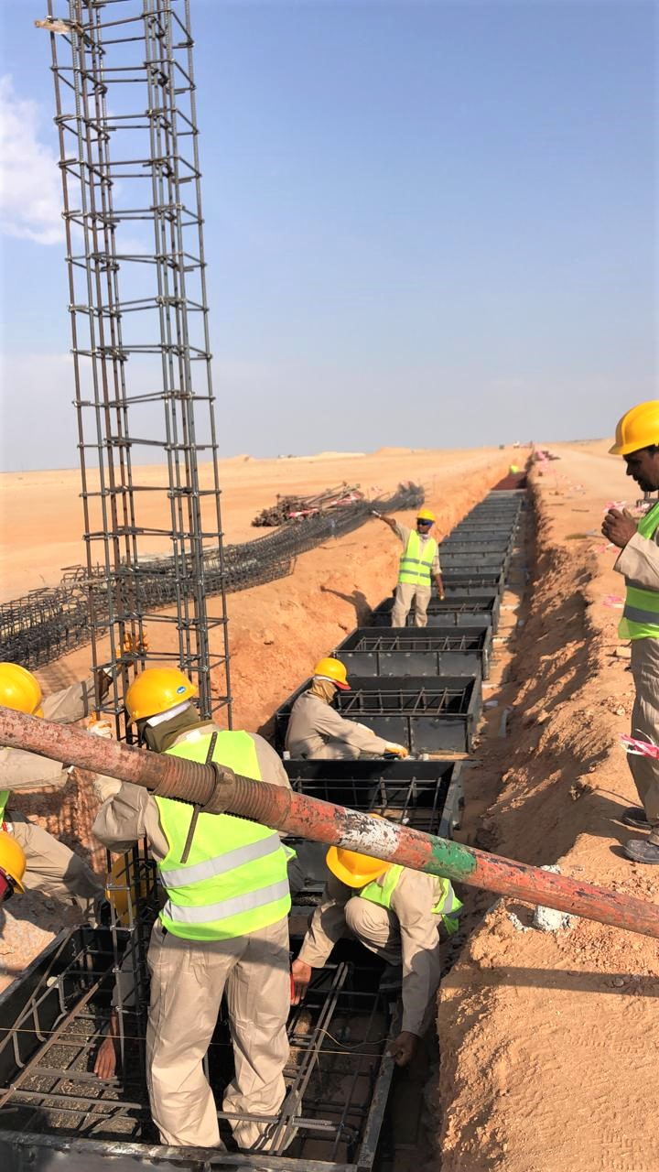
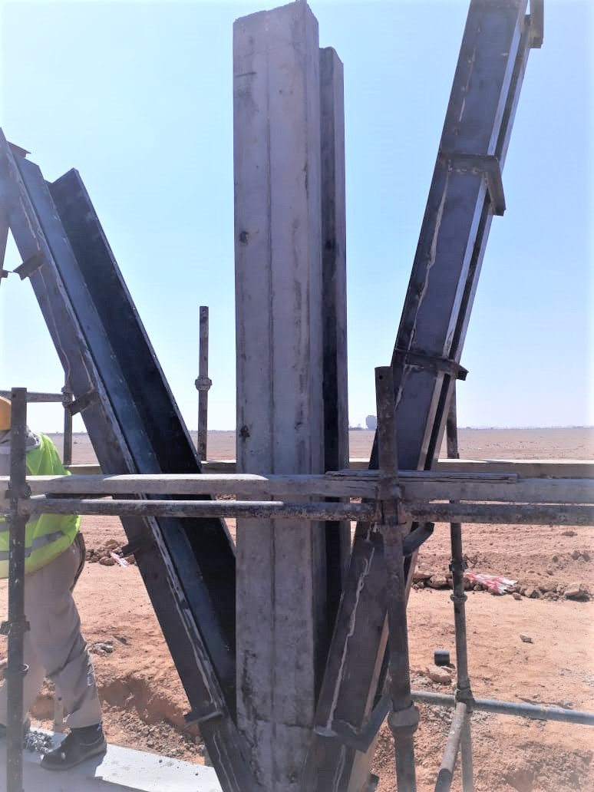

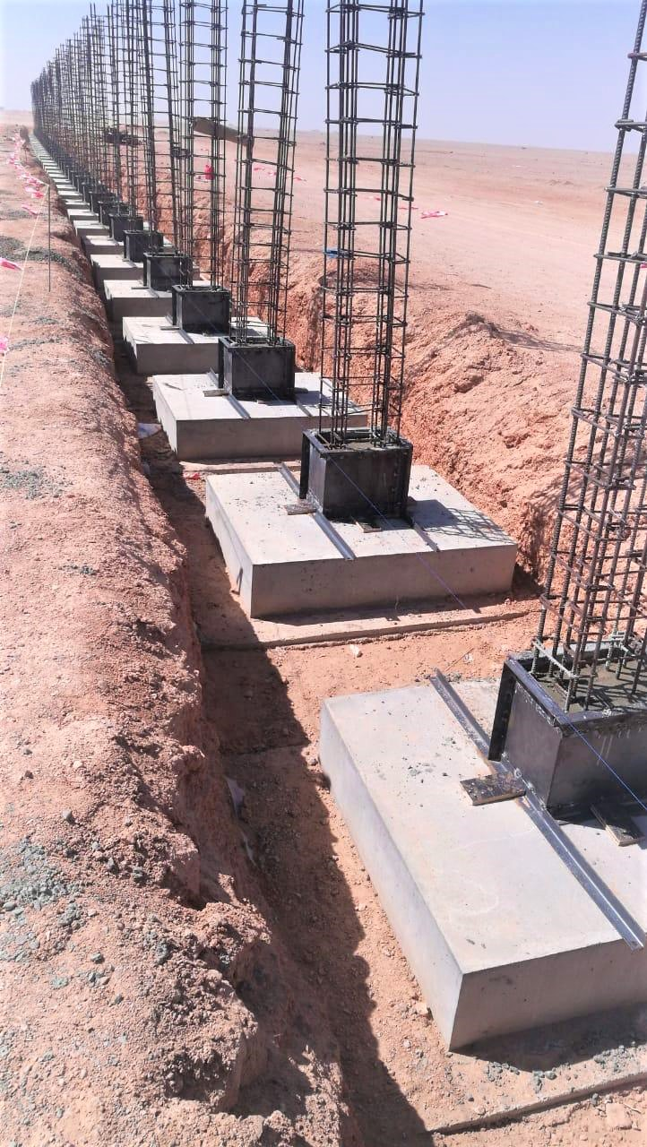
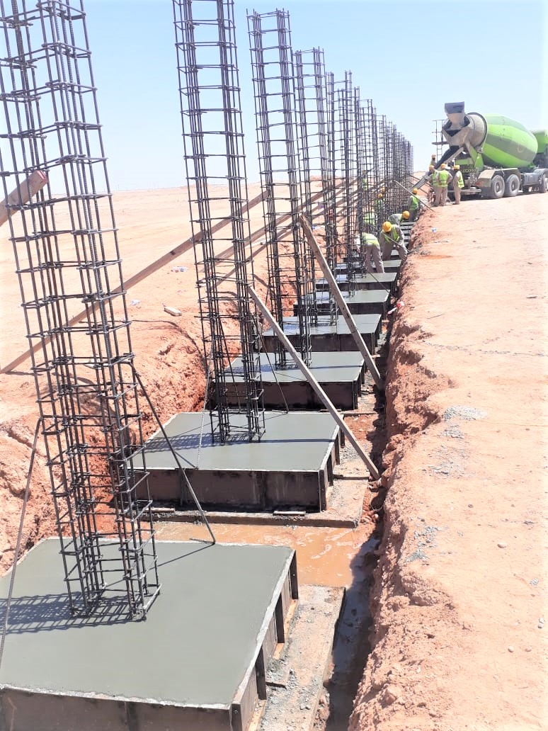

Al-Malik Al-Masiah Trading & Contracting L.L.C
Al Turky Enterprises L.L.C (Construction of Hotel & Residential building Ghala - Muscat)
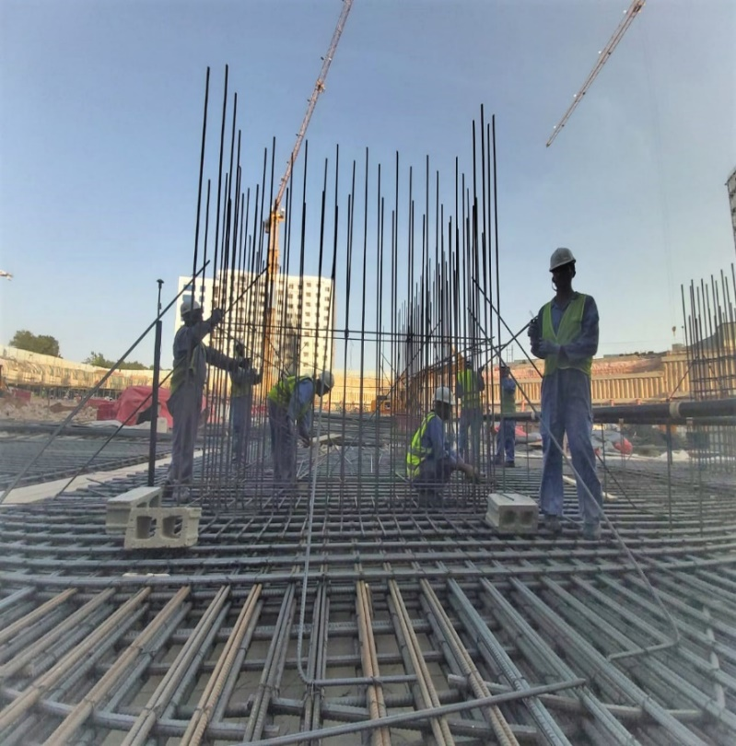
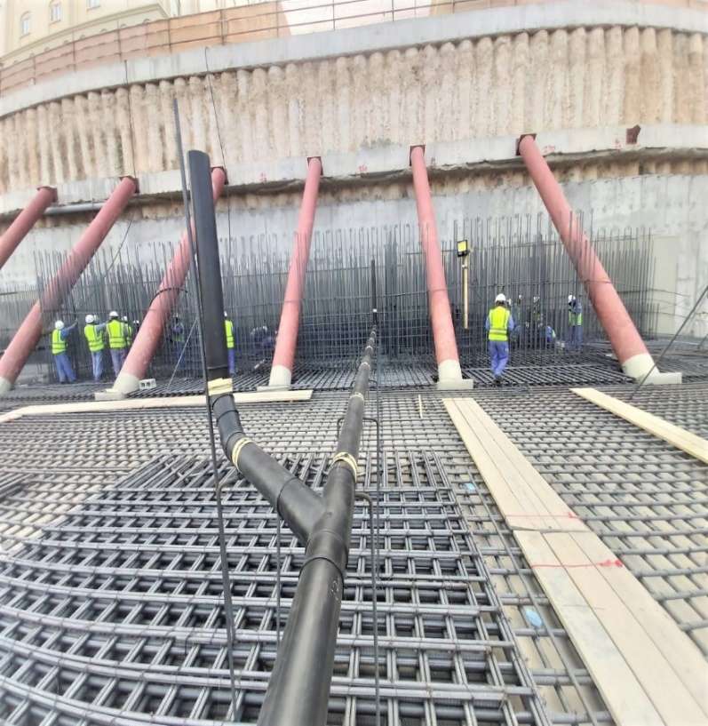

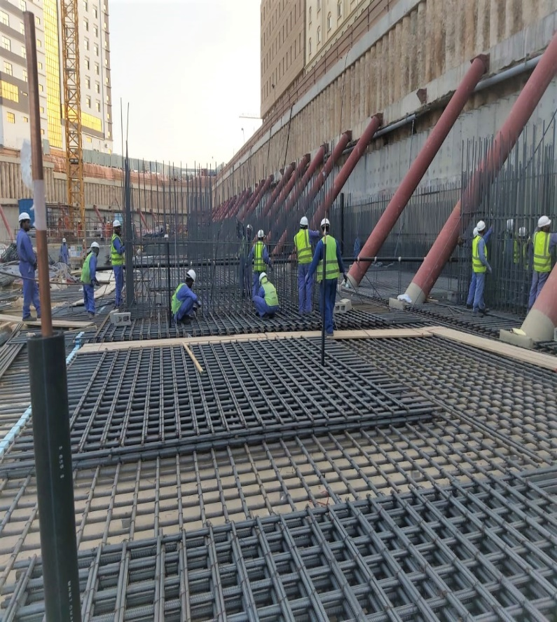
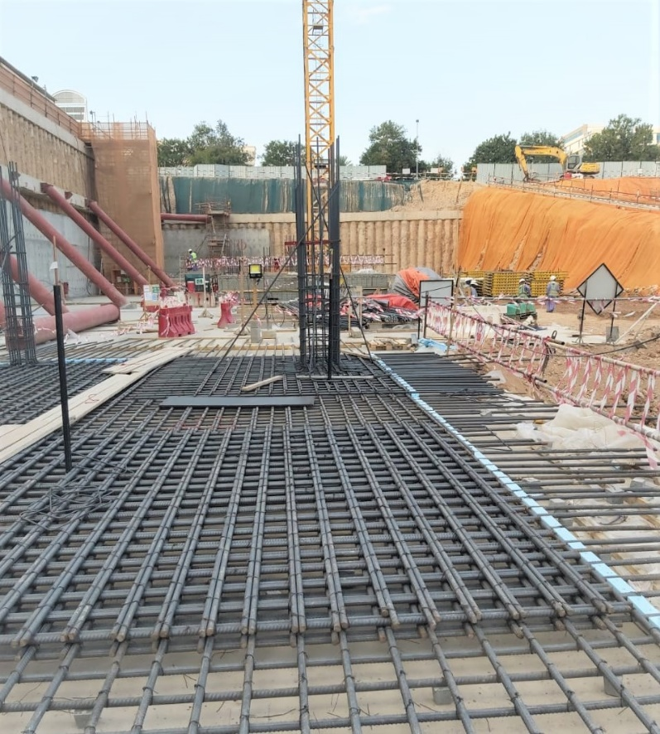

Al-Malik Al-Masiah Trading & Contracting L.L.C
Al-Hassan Hi-tech Services (PAEW-DAIM (Up-Grading of pumping station Barka Muscat)
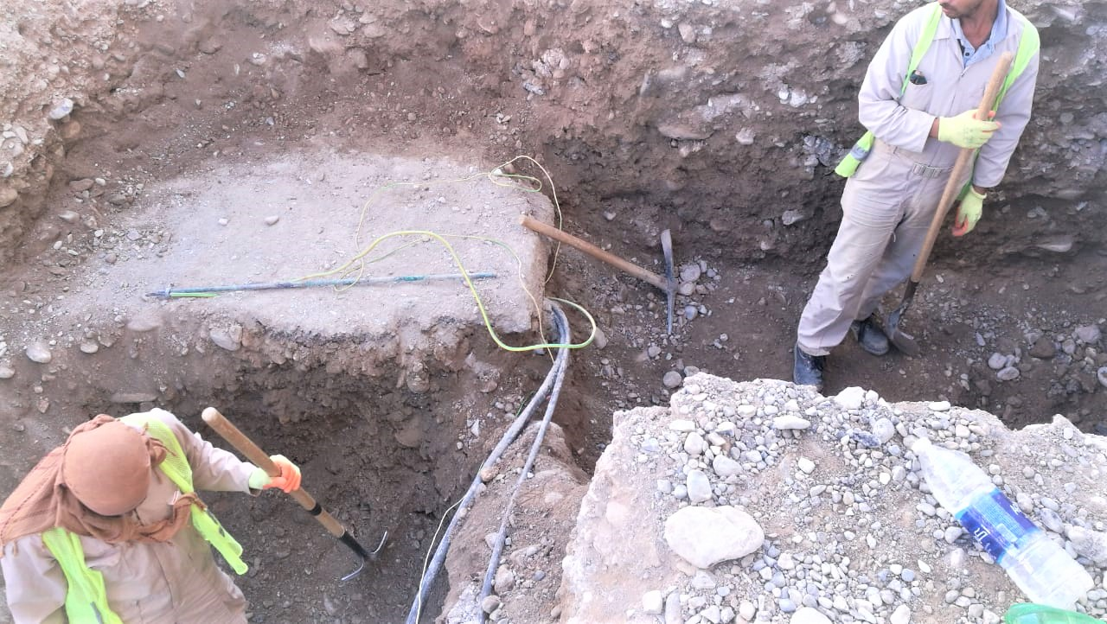

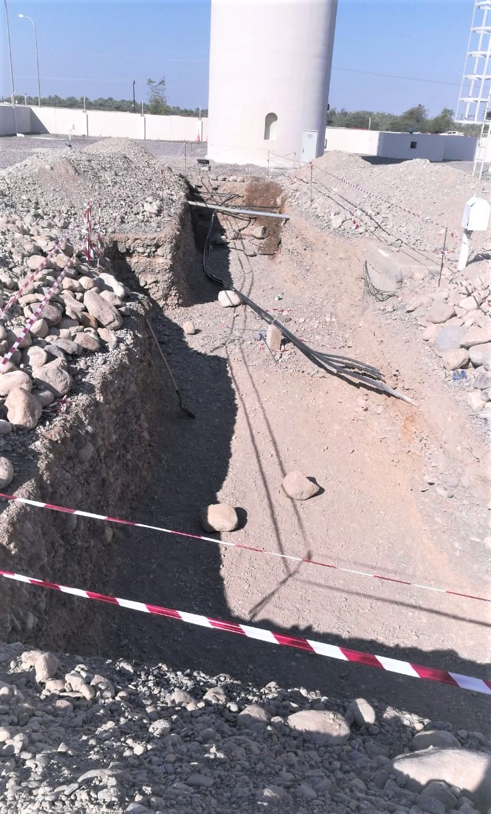
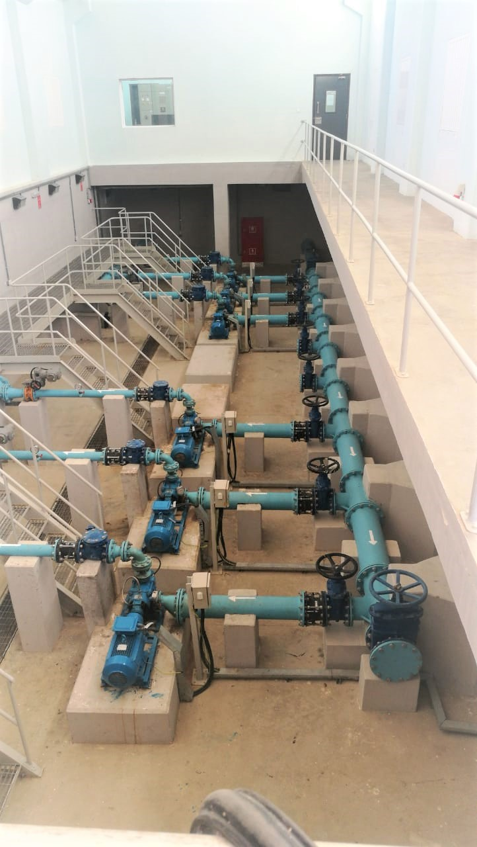

Al-Malik Al-Masiah Trading & Contracting L.L.C
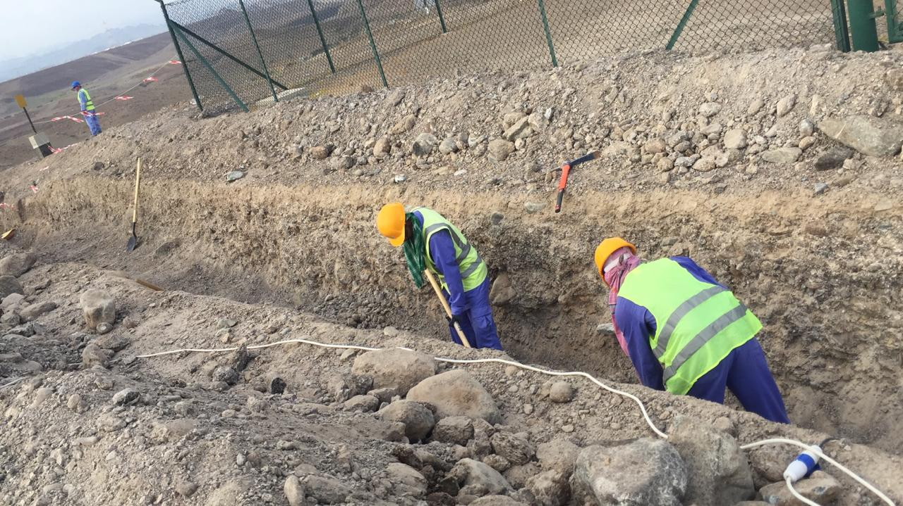
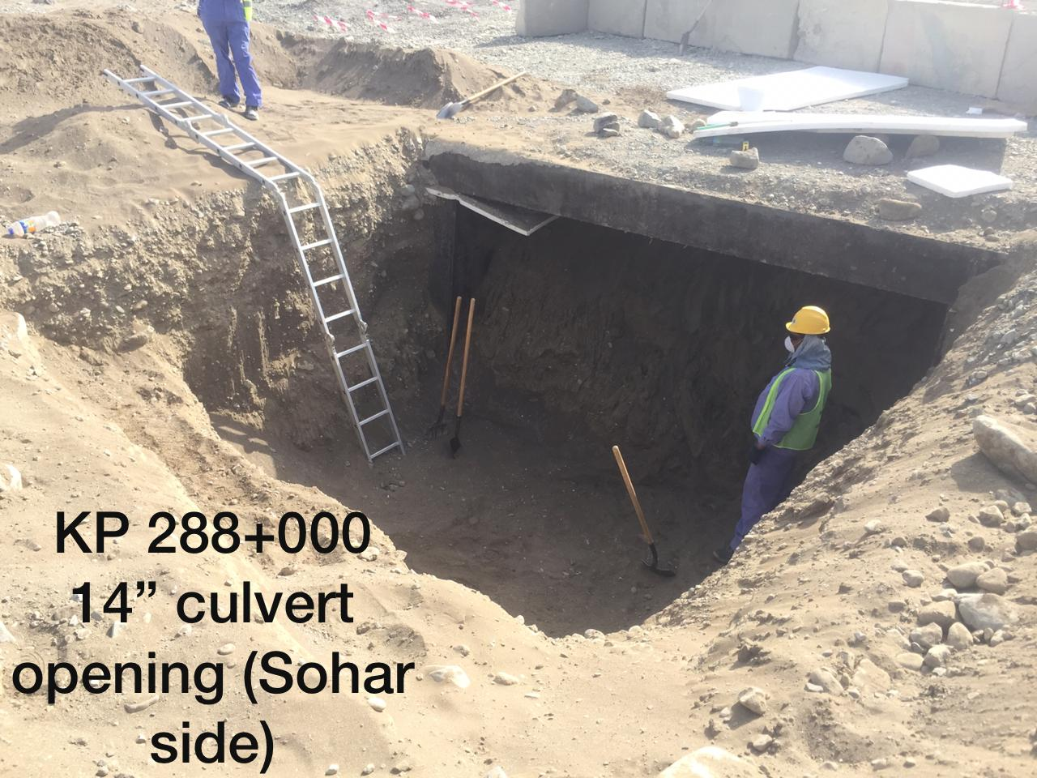
Punj Lloyd Limited Oman-PLL (ORPIC &Oman Gas Company - Earth Work Spread 1 & 2) Fahud to Sohar 300km
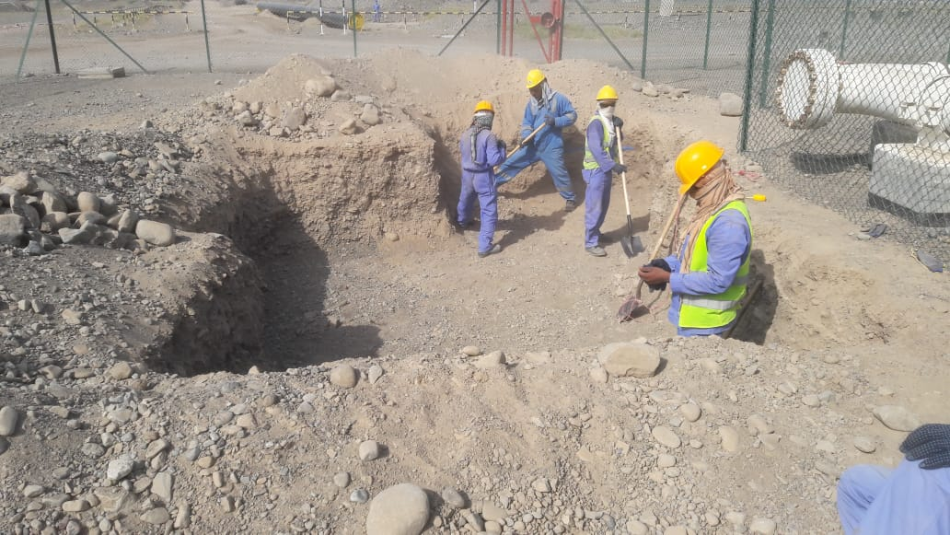

Al-Malik Al-Masiah Trading & Contracting L.L.C
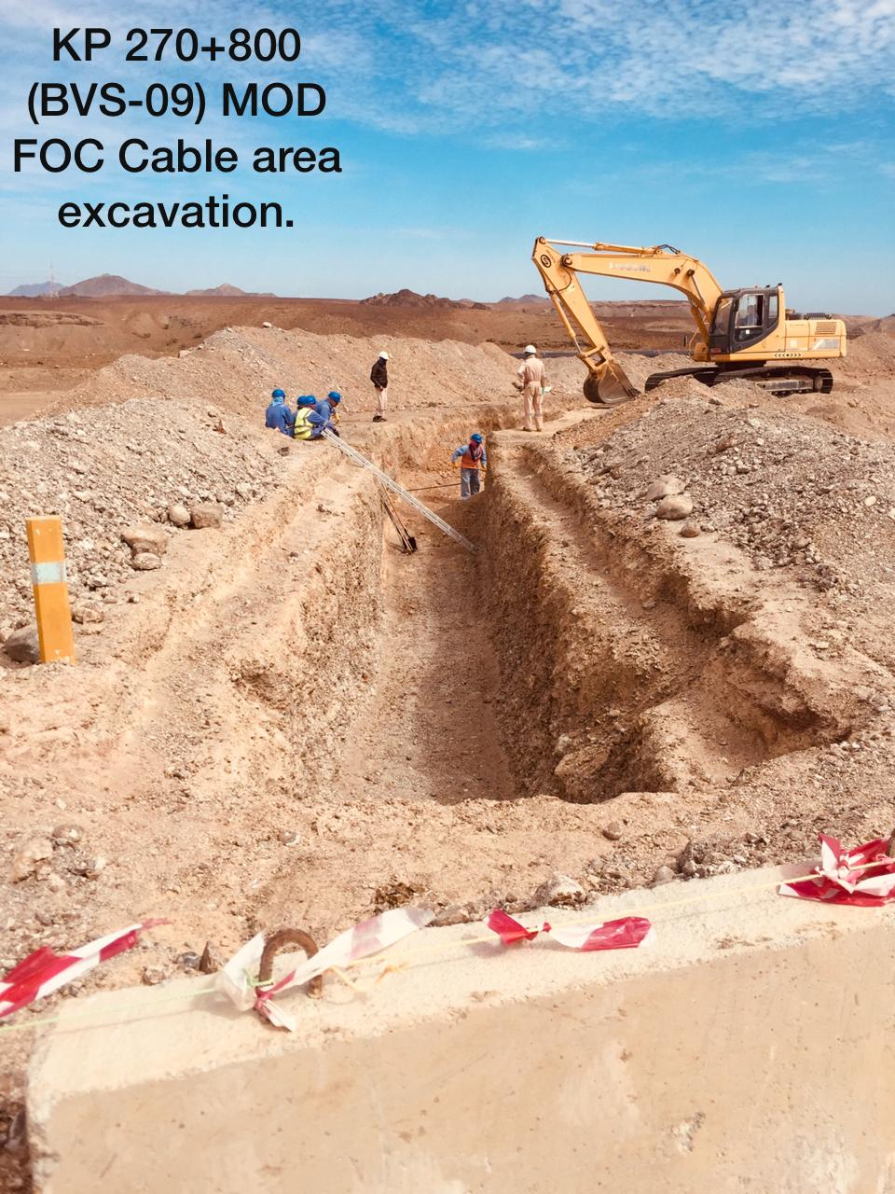
Punj Lloyd Limited Oman-PLL (ORPIC & Oman Gas COMPANY -CWC Pipe Coating 32" & 14")

Al-Malik Al-Masiah Trading & Contracting L.L.C
Punj Lloyd Limited Oman-PLL (ORPIC &Oman Gas Company - Concrete Work Spread 1 & 2) Fahud to Sohar 300km
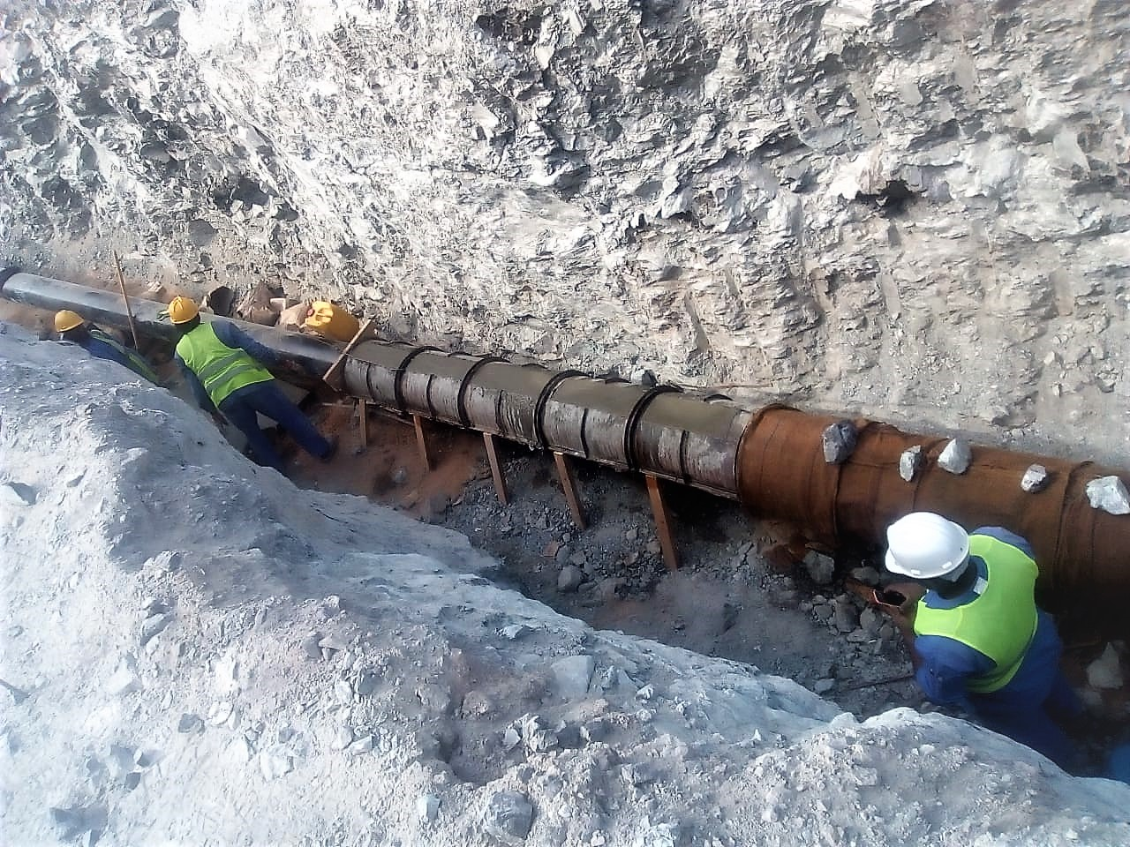
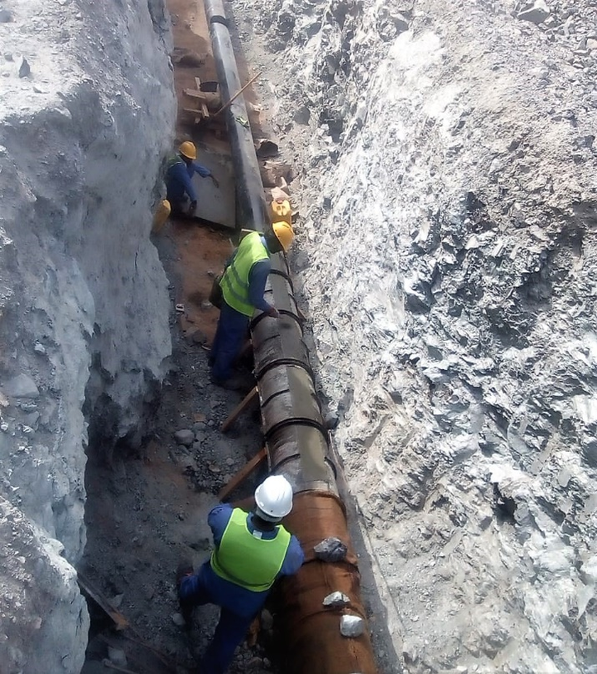
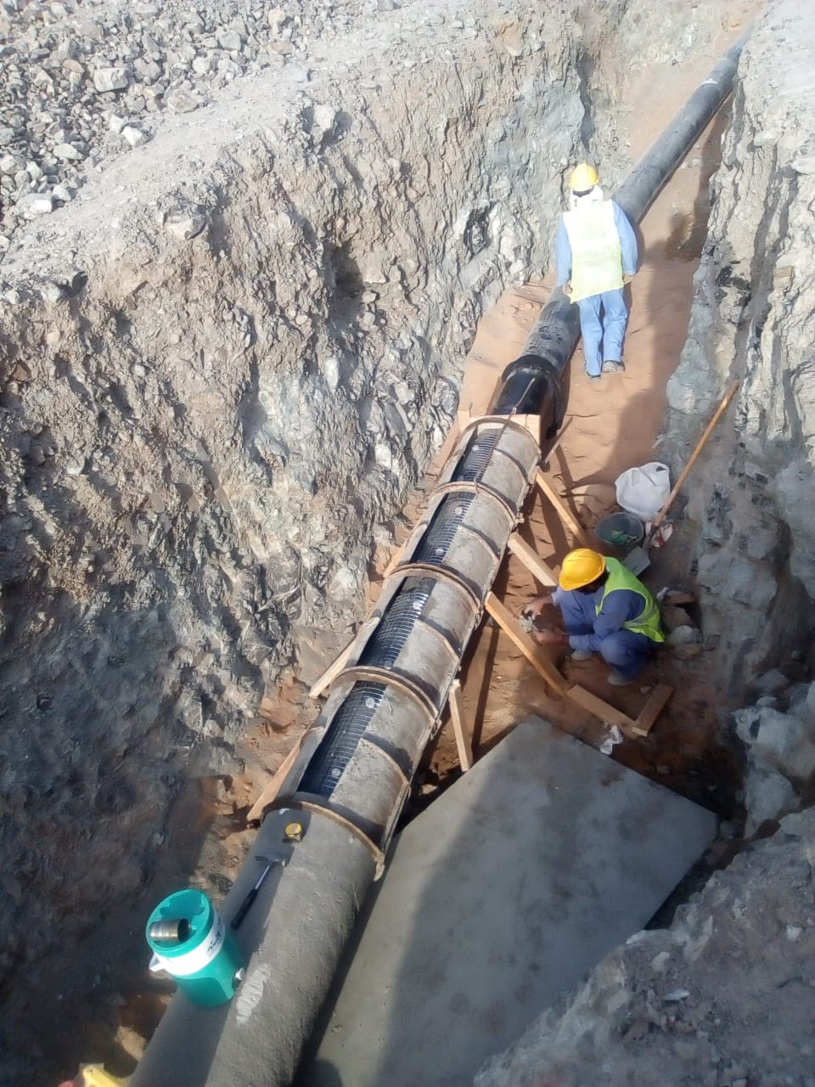

Al-Malik Al-Masiah Trading & Contracting L.L.C
Al-Hassan Hi-Tech Services
Common Cooling Water System (Majis Sohar Port)

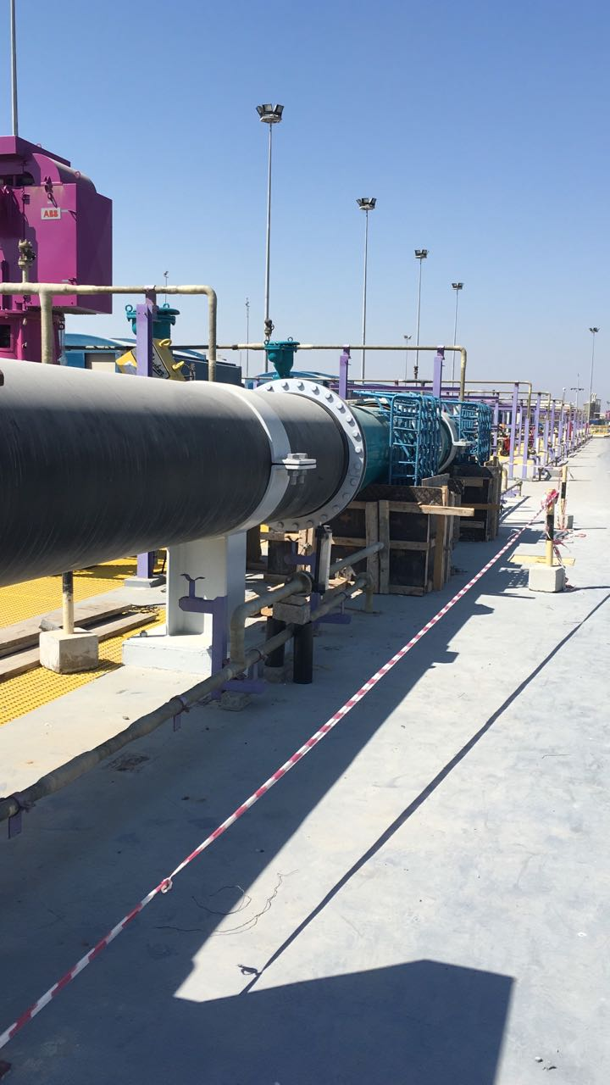
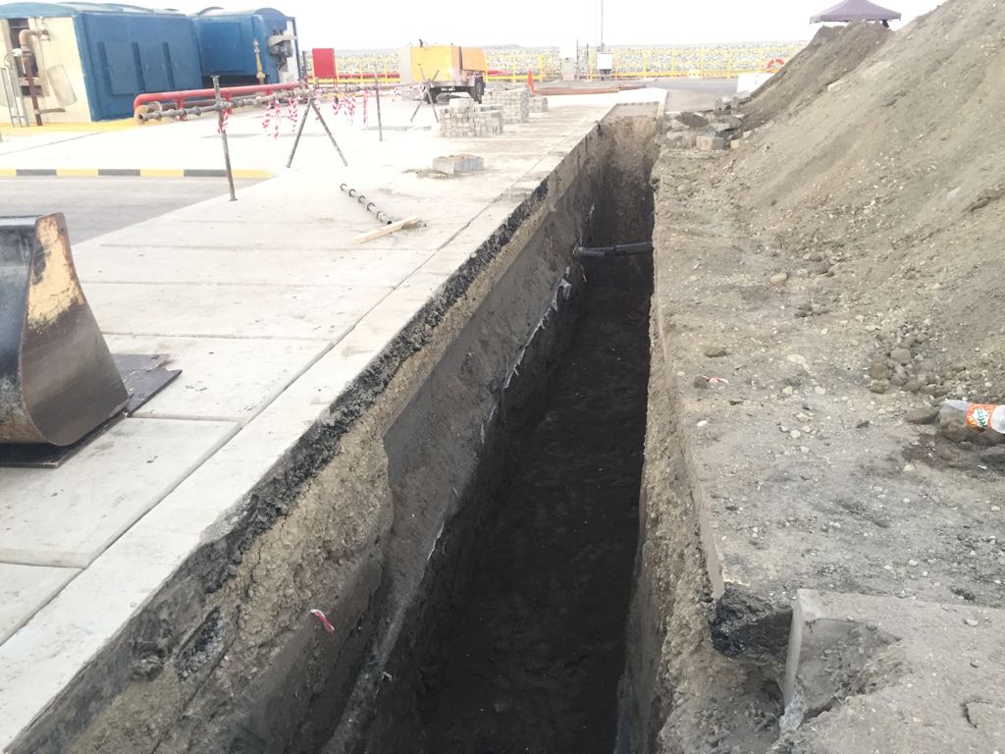

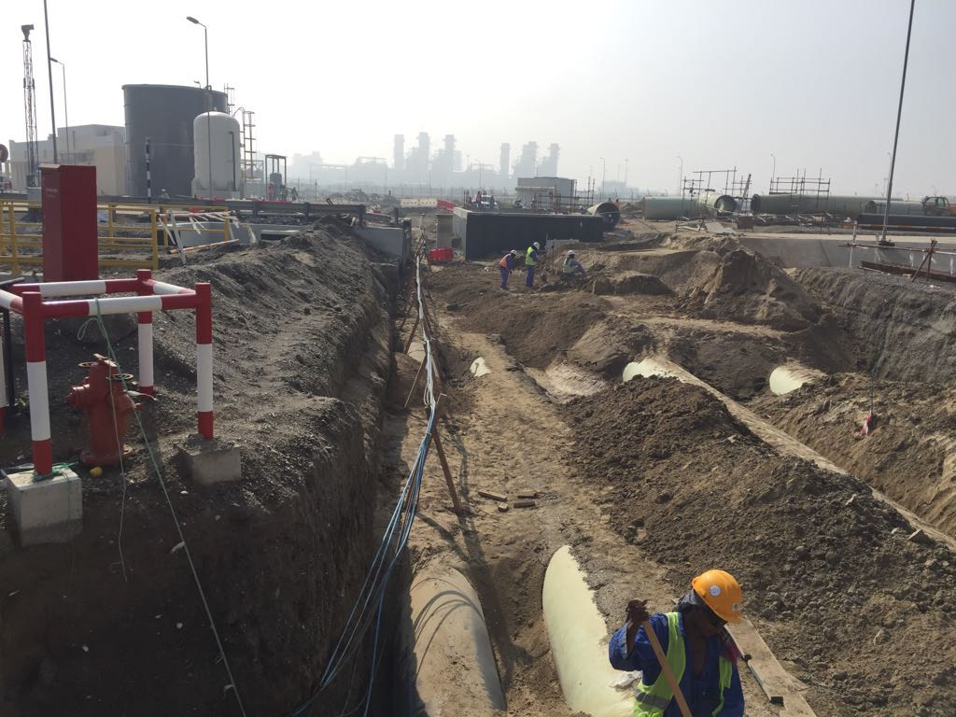
Al-Malik Al-Masiah Trading & Contracting L.L.C
Descon Engineering L.L.C -Oman (Construction of workshop at Sohar Industrial)
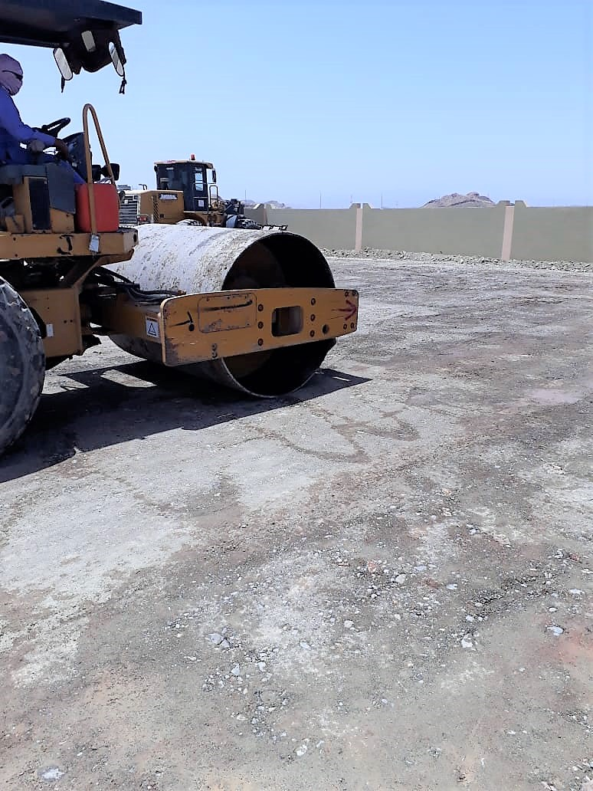
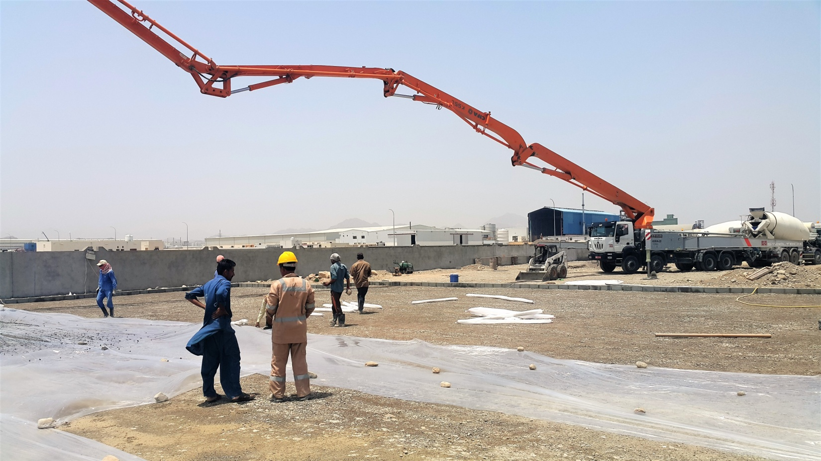
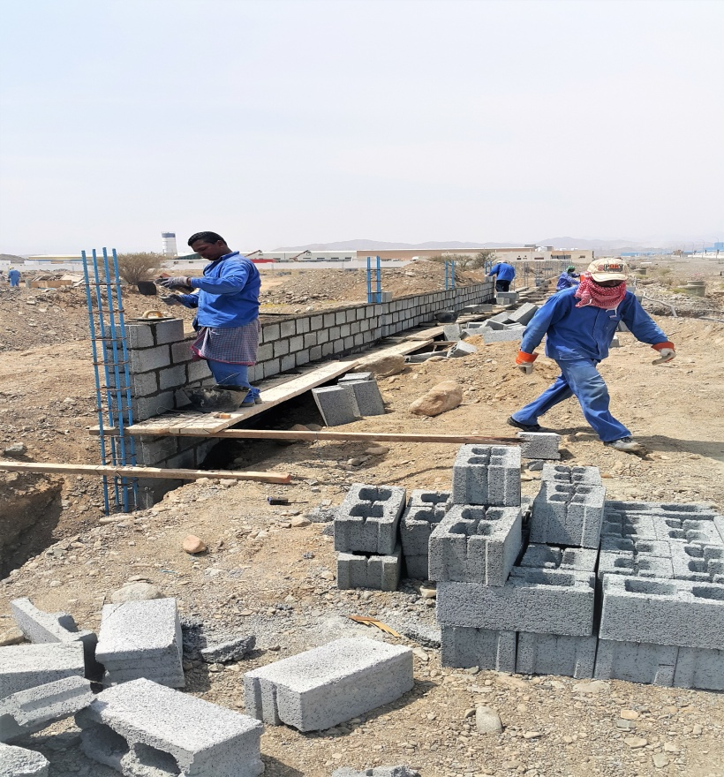

Al-Malik Al-Masiah Trading & Contracting L.L.C
Saudi National Contracting (SNCC) Misfa-Izki 400KV line Transmission
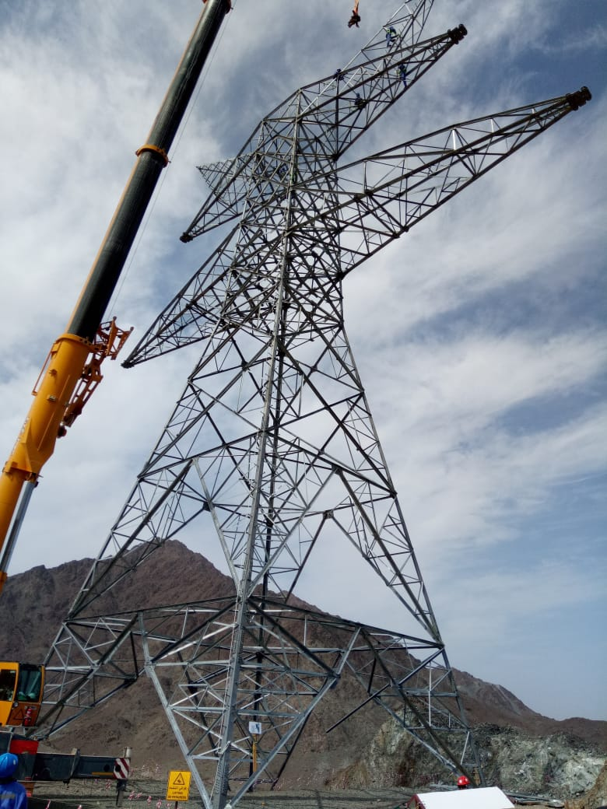
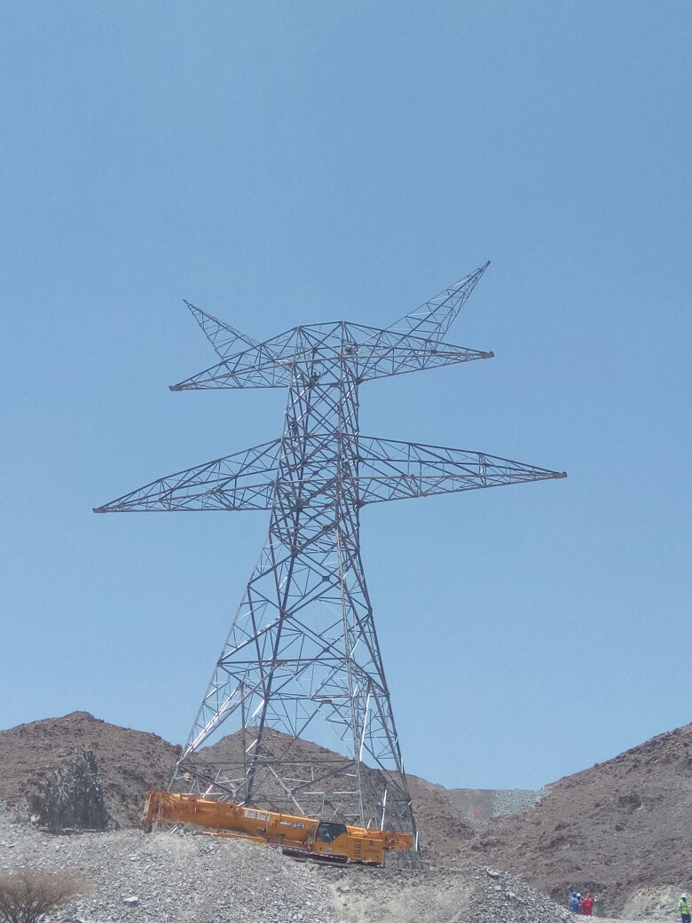
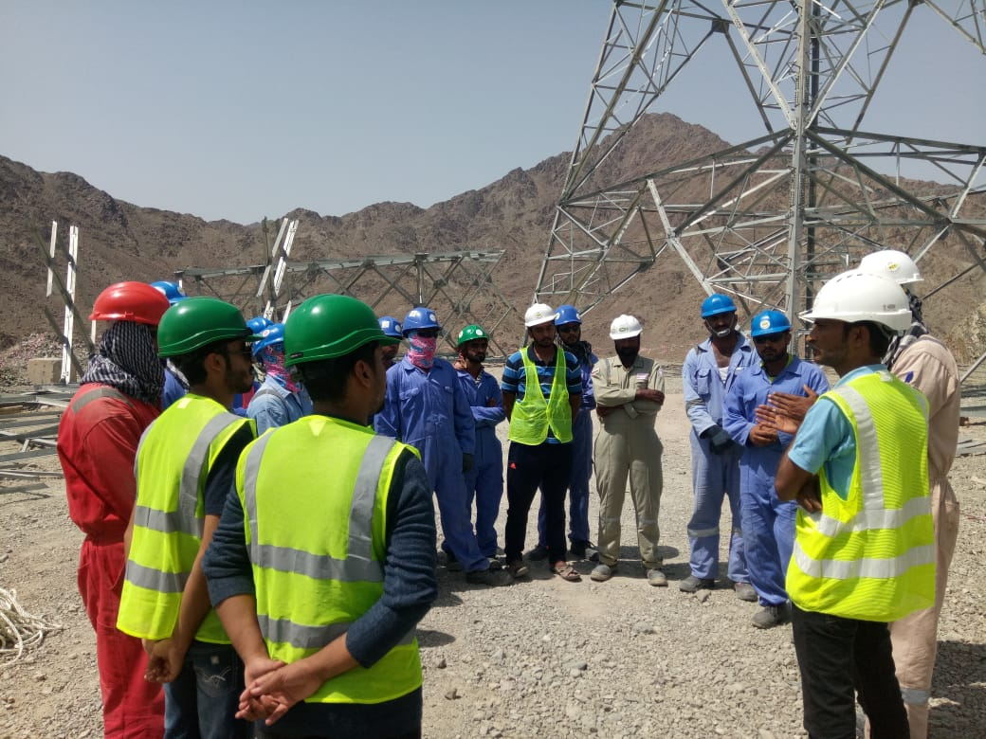
Al-Malik Al-Masiah Trading & Contracting L.L.C
Saif Salem Al Jabri Two Twin Villas - Sohar Tareef 260,261
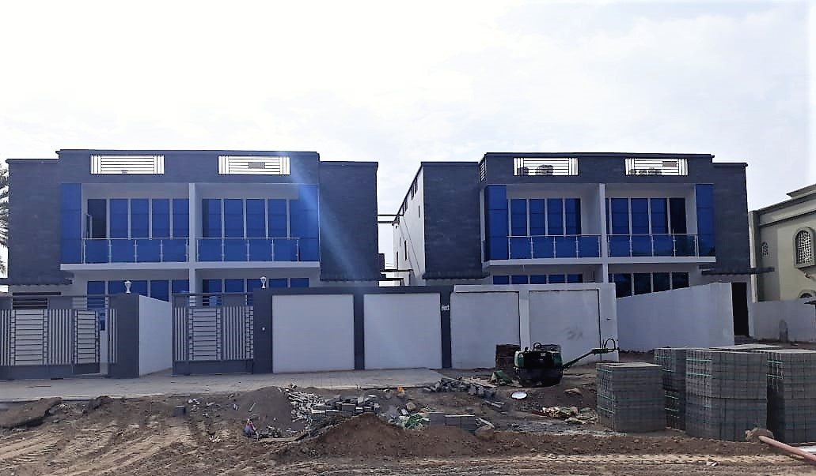
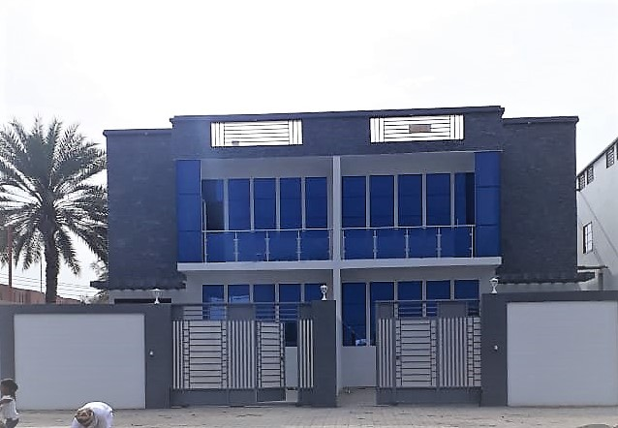

Al-Malik Al-Masiah Trading & Contracting L.L.C
Saif Salem Al Jabri Three Villas - Sohar Falaj Al Ouhi 584
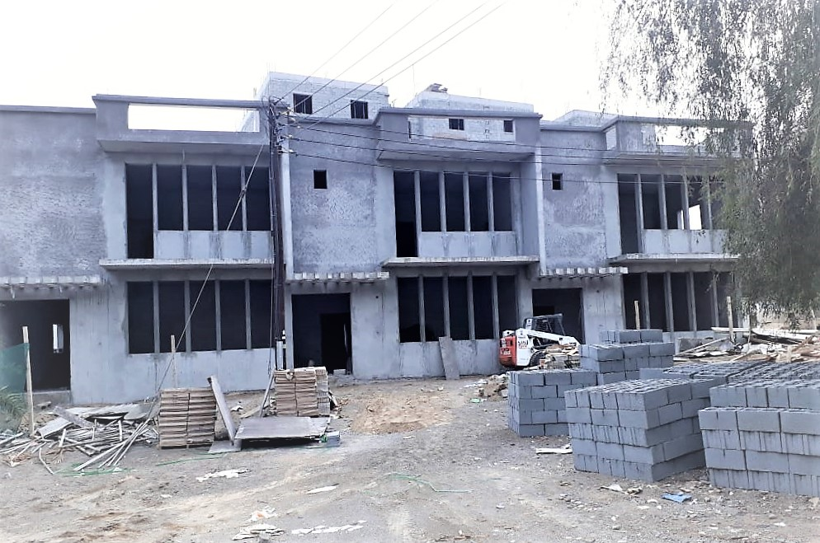
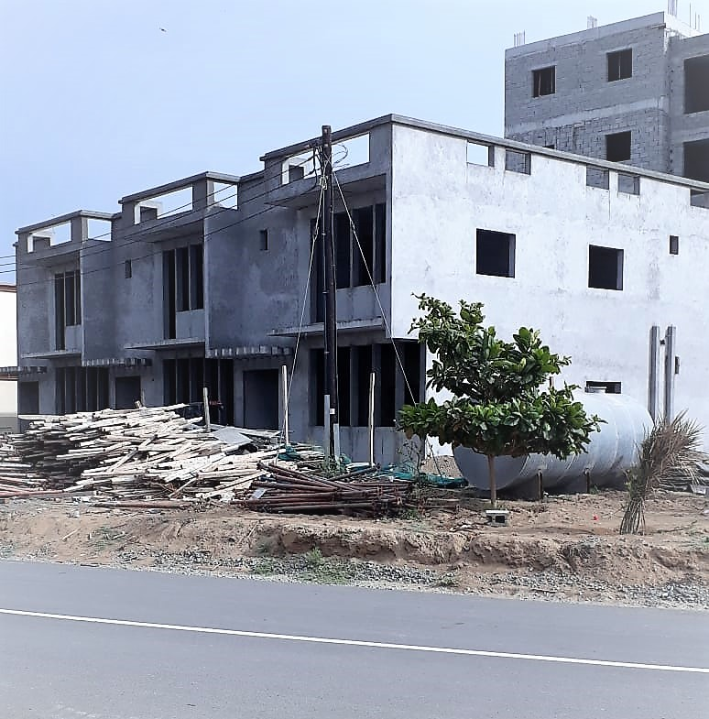
Al-Malik Al-Masiah Trading & Contracting L.L.C
MIH Group-UAE Construction of Aluminum Factory & Store Sohar 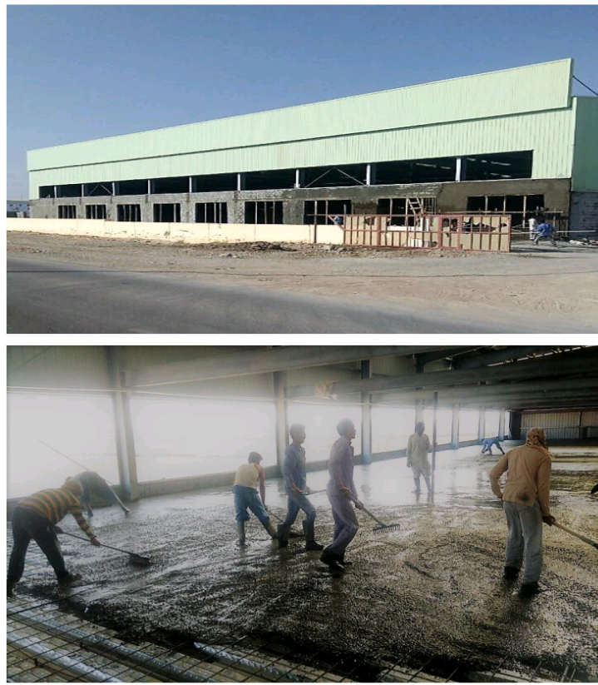
Al-Malik Al-Masiah Trading & Contracting L.L.C
Musbah International L.L.C - Construction of Commercial Building Ouhi Sanaya Sohar

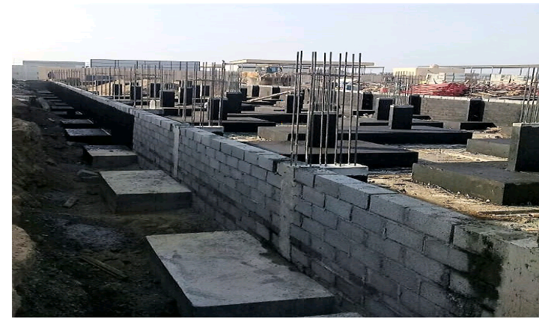
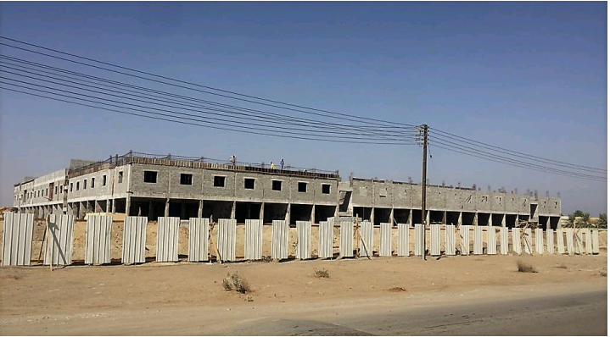
Al-Malik Al-Masiah Trading & Contracting L.L.C
Bahwan Engineering Company L.L.C Liwa Plastic Project
(Concrete Structural Work) Sohar Port

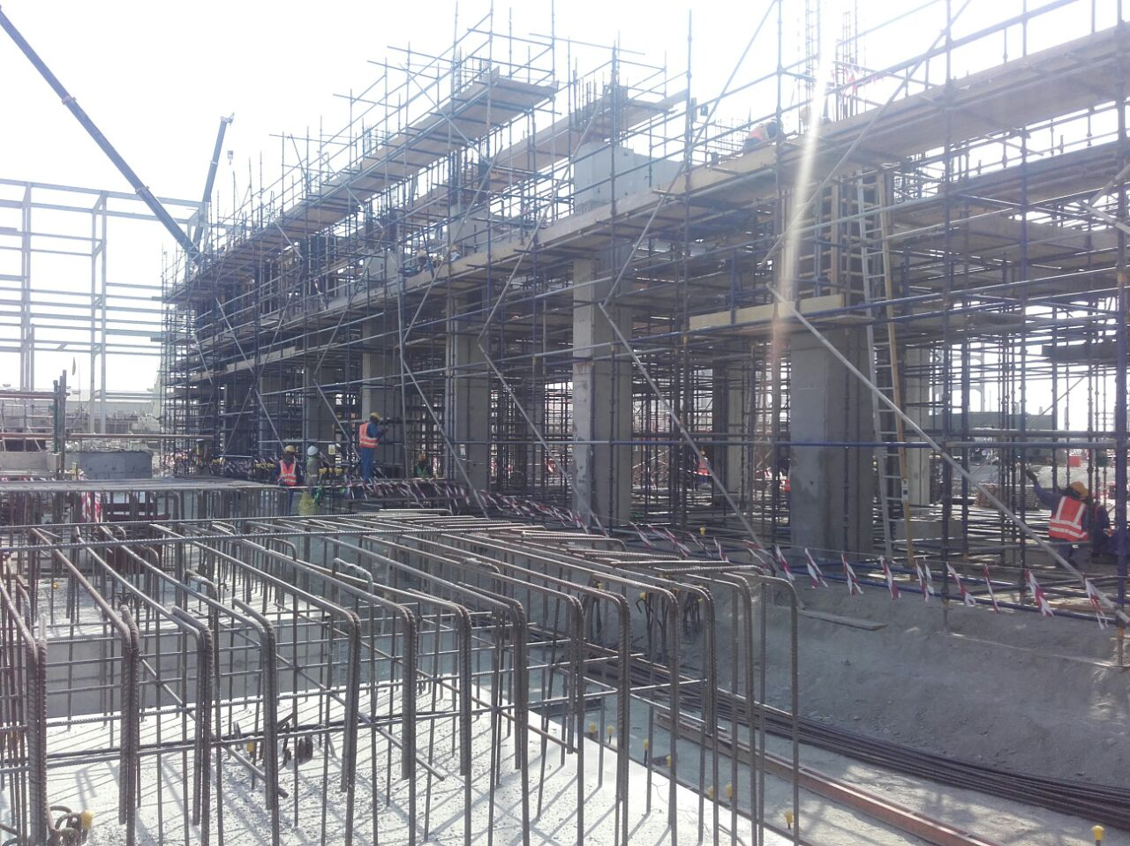
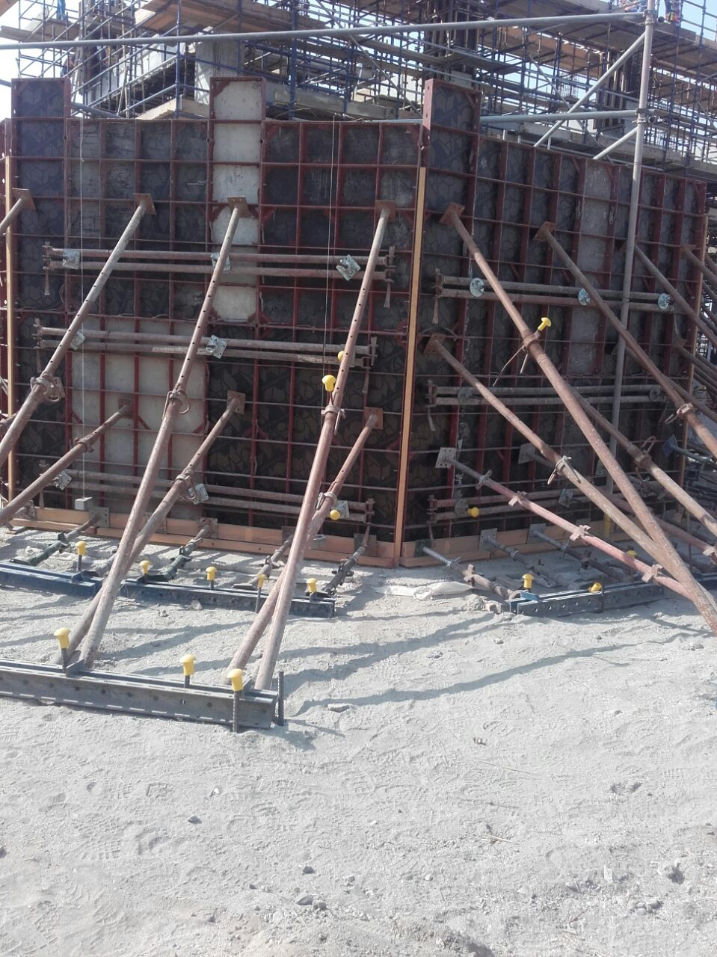

Al-Malik Al-Masiah Trading & Contracting L.L.C
Al-Hassan Engineering L.L.C Liwa Plastic Project Sohar (Rip Rap)
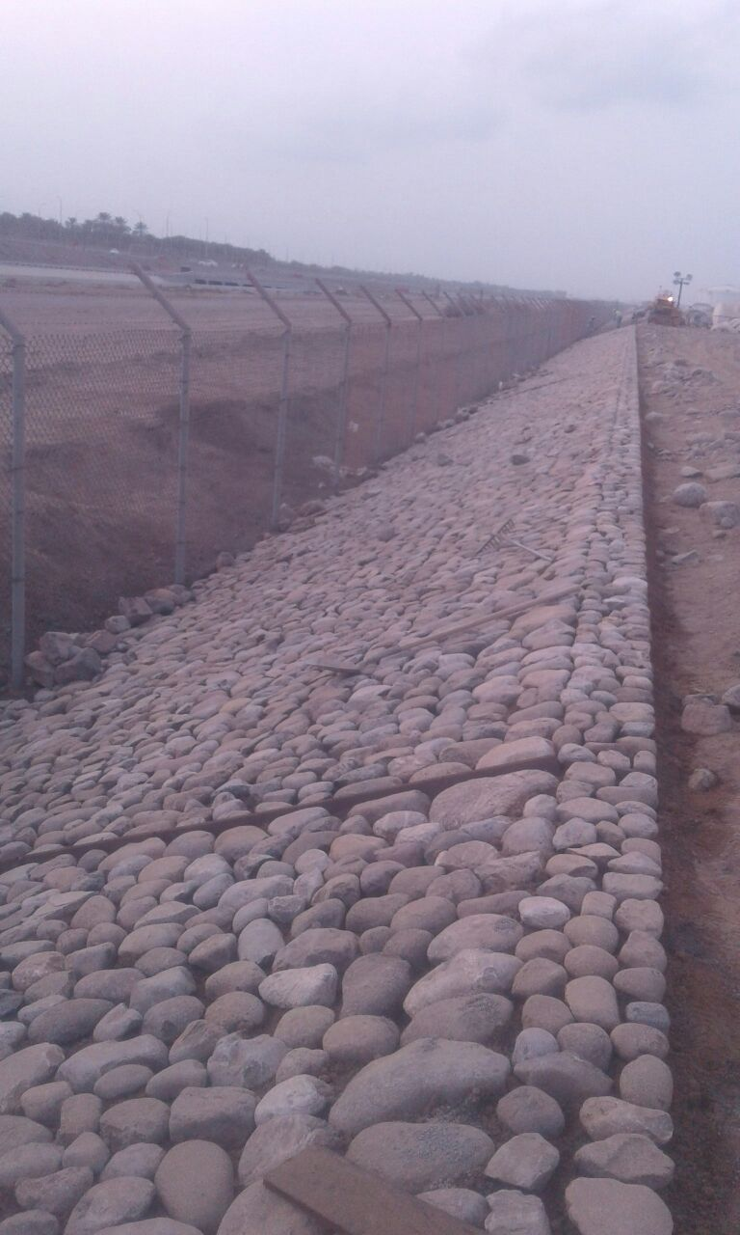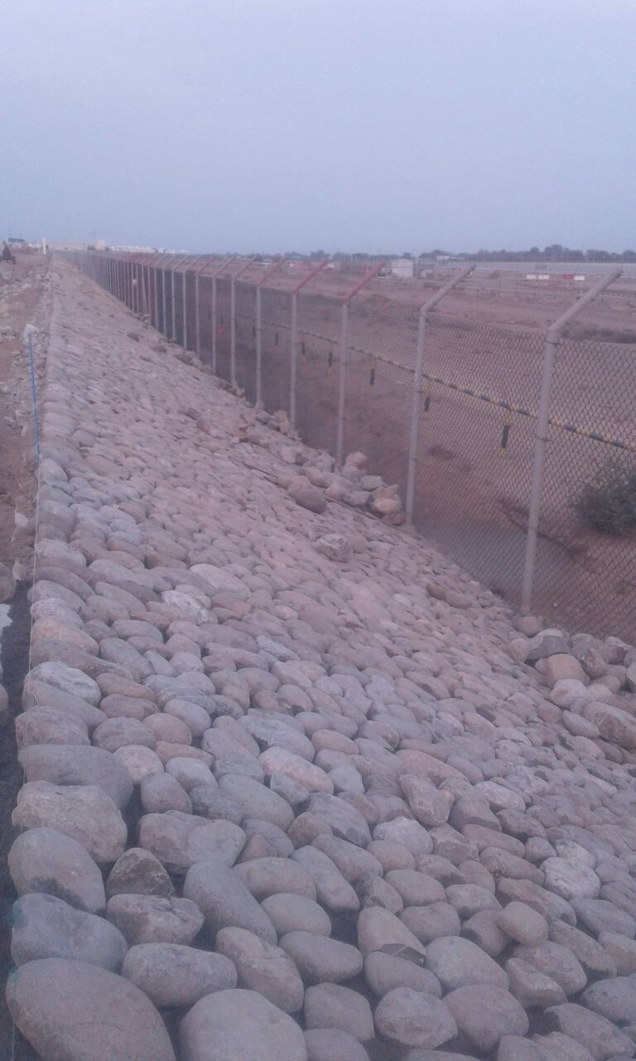
Al-Malik Al-Masiah Trading & Contracting L.L.C
University of Buraimi (Food Oasis Building)
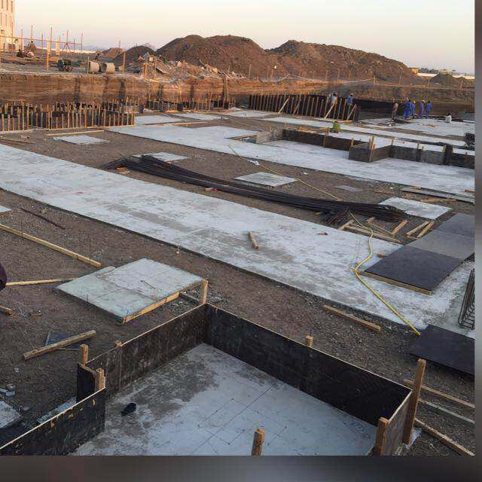
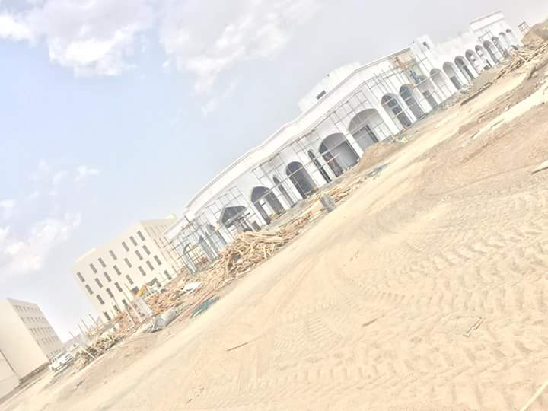
Al-Malik Al-Masiah Trading & Contracting L.L.C
Larsen & Toubro L.L.C (University of Buraimi Project)
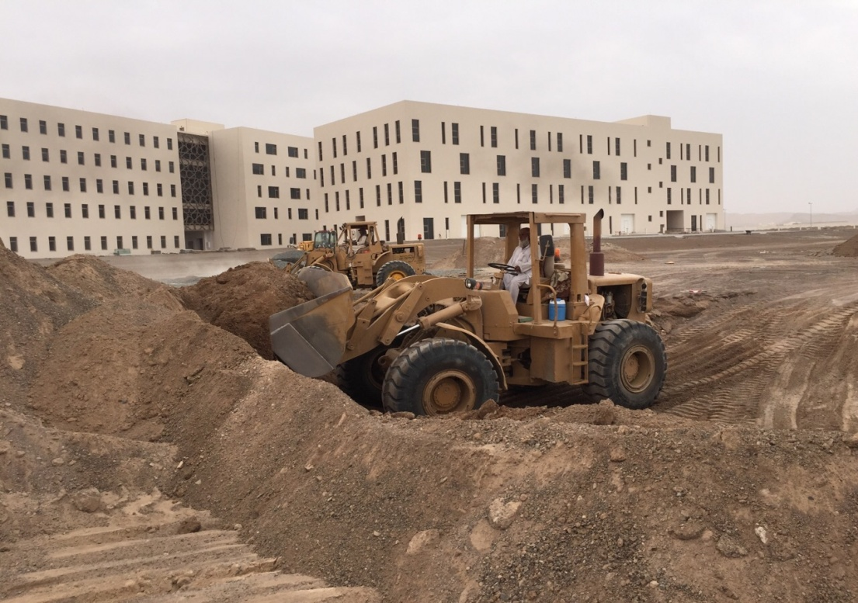
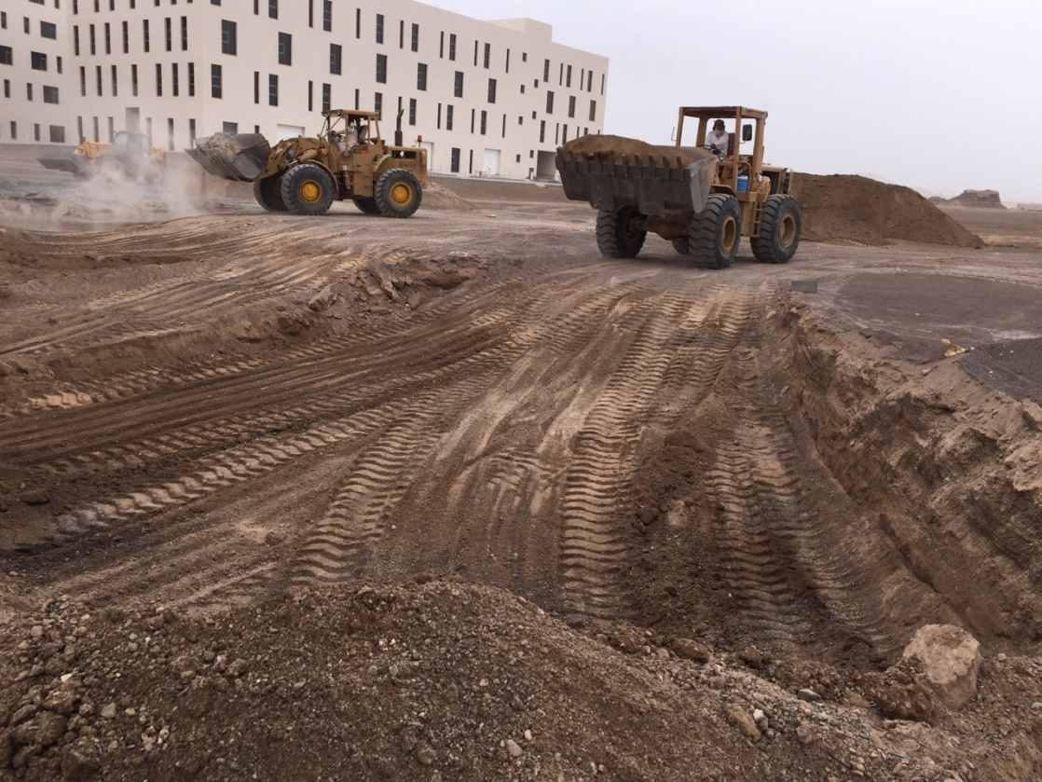

Al-Malik Al-Masiah Trading & Contracting L.L.C
Sohar-Buraimi Road Project (CCC & Apex Global)
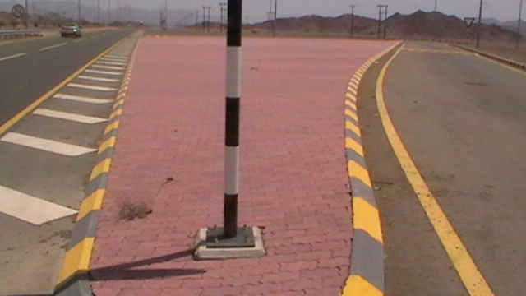
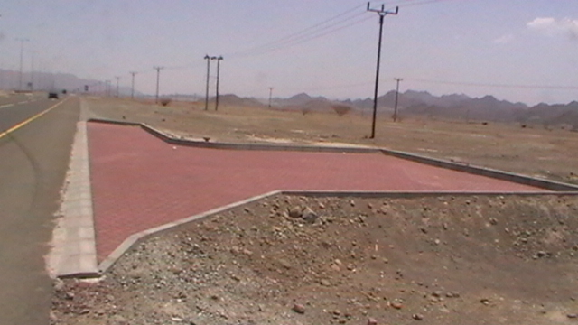
Al-Malik Al-Masiah Trading & Contracting L.L.C
Meethaq Islamic Bank (Amjaad Contracting & Consulting)
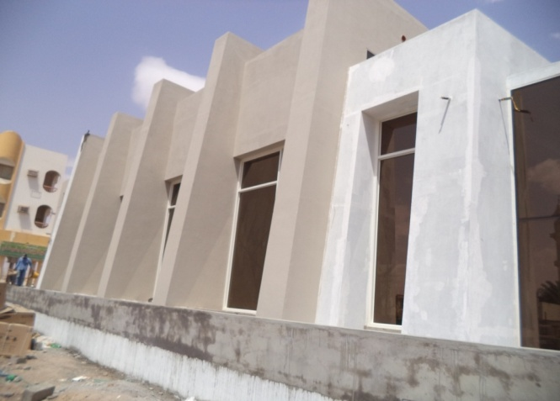
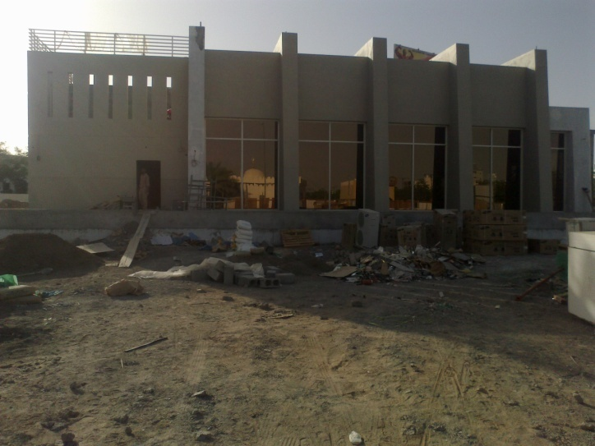

Al-Malik Al-Masiah Trading & Contracting L.L.C
Hassan Juma Backer (Rip Rap in & out side Port Sohar)
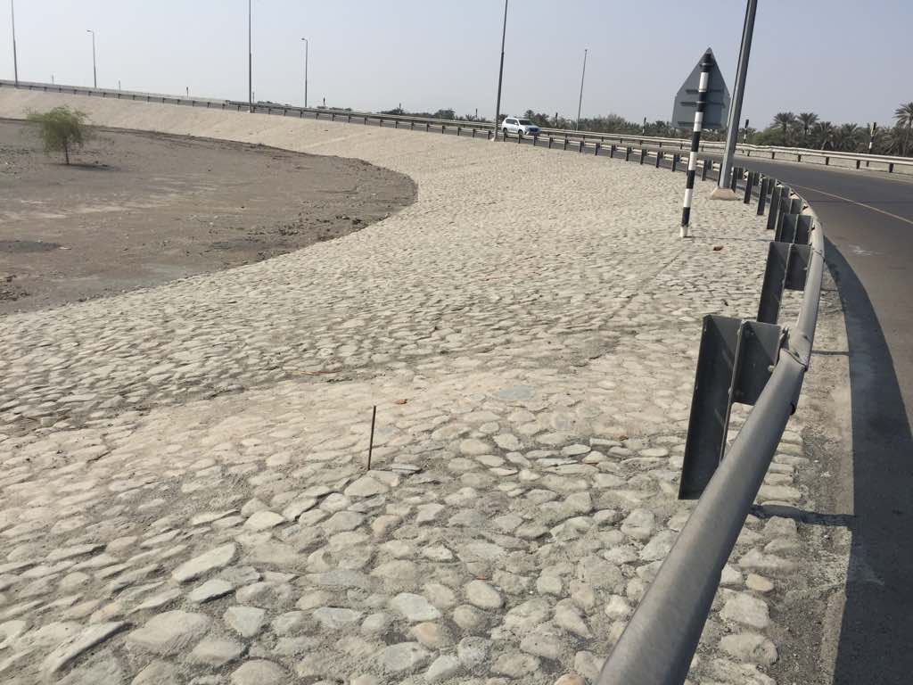
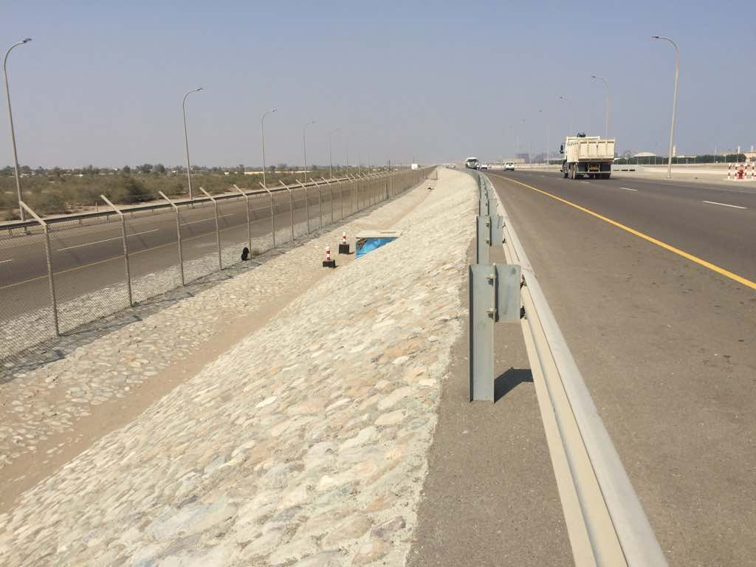

Al-Malik Al-Masiah Trading & Contracting L.L.C
Al-Ansari Contracting L.L.C (Parking of Sultan Qaboos Mosque Mahda)
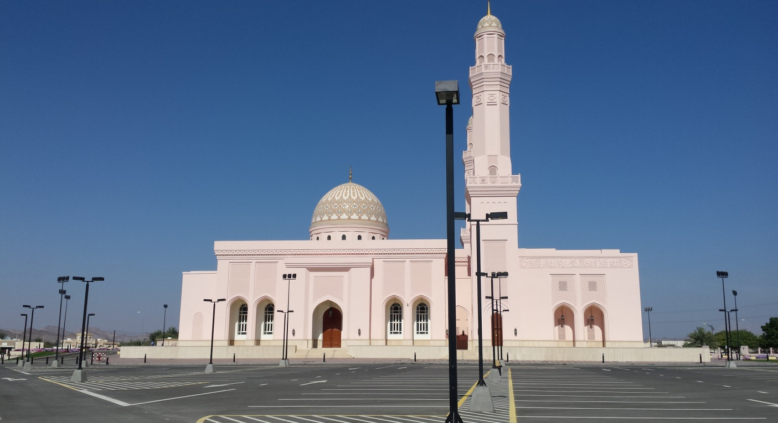
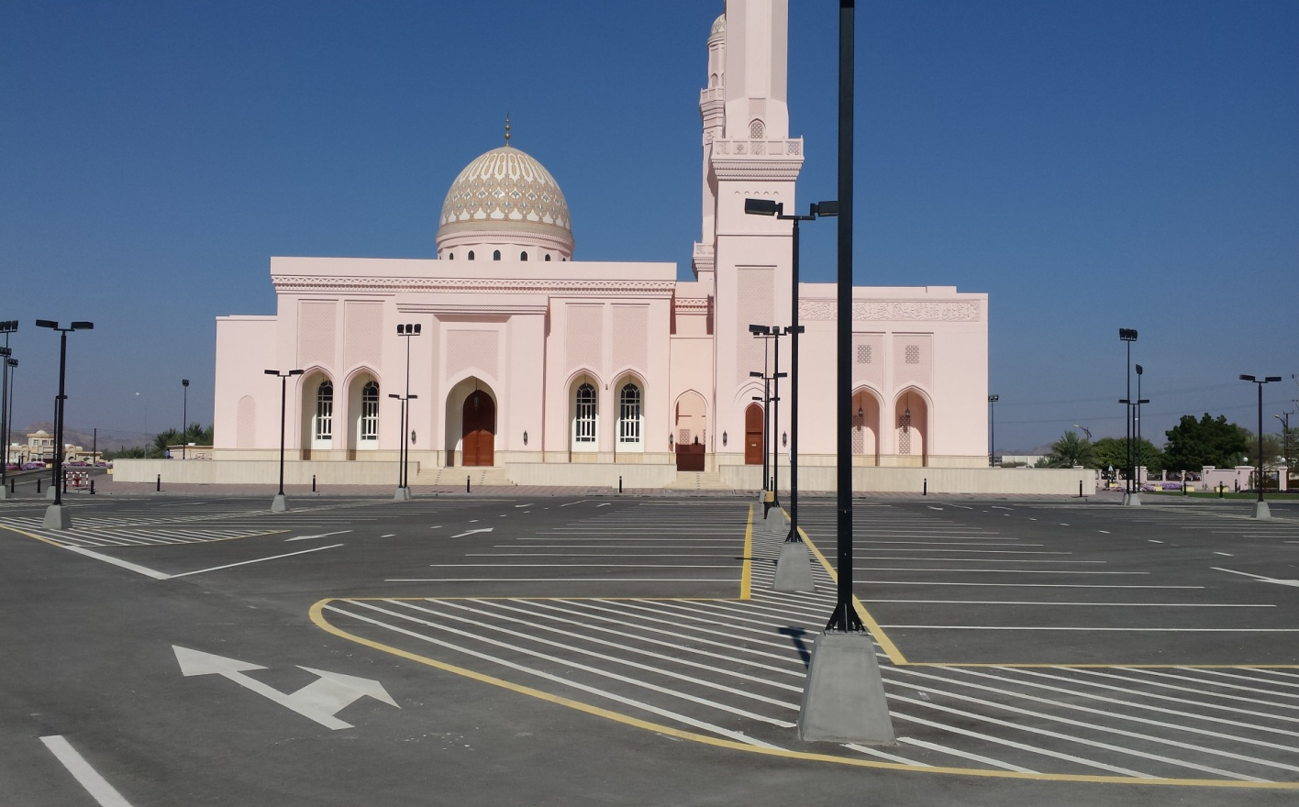

Al-Malik Al-Masiah Trading & Contracting L.L.C
Global Chemical L.L.C (11-KV Sub-Station Buraimi & Nizwa)
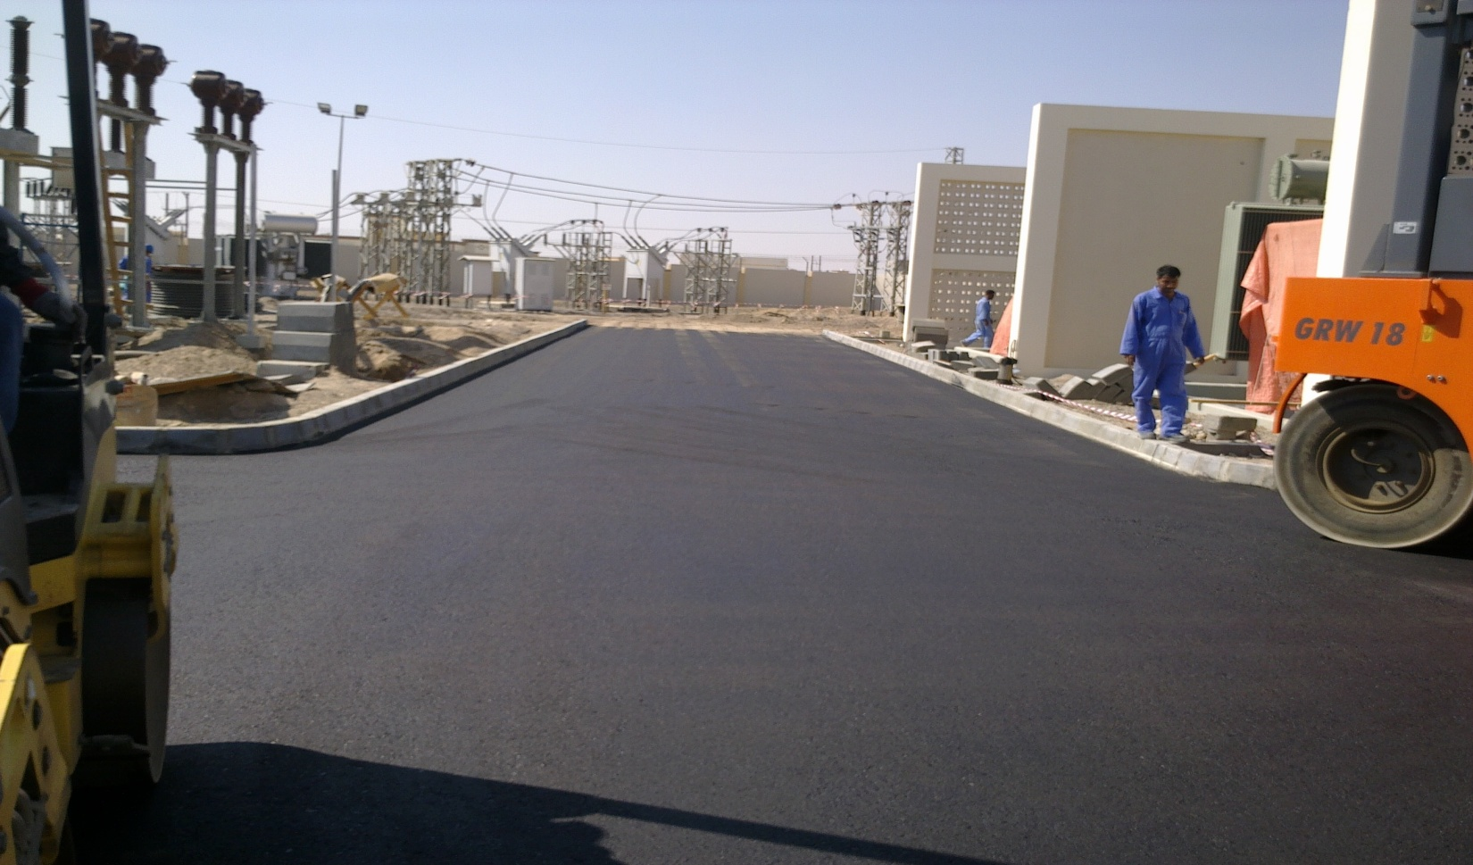
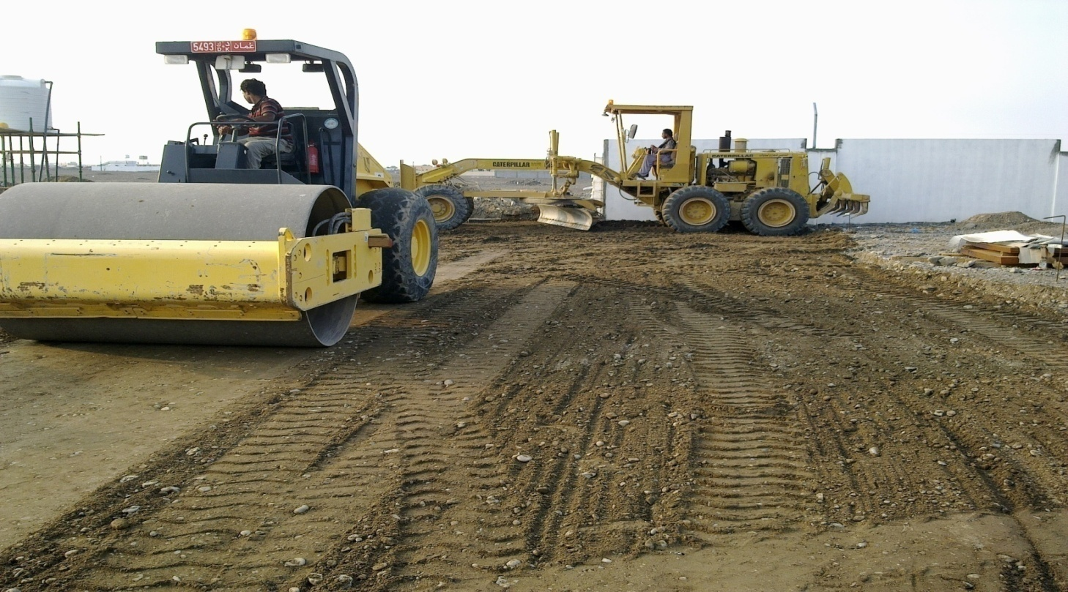
Al-Malik Al-Masiah Trading & Contracting L.L.C
Global Chemical L.L.C (STP/ Royal Oman Police Al-Aswad Shinas)
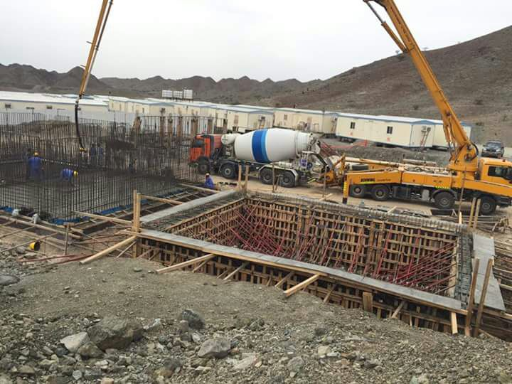
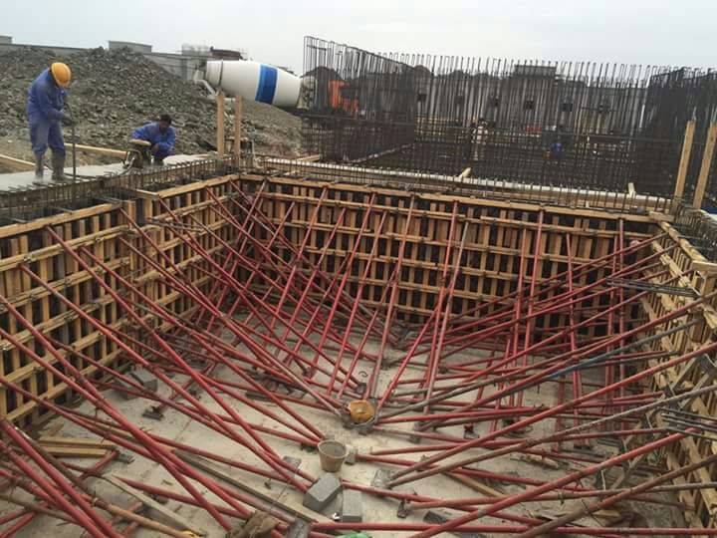
Al-Malik Al-Masiah Trading & Contracting L.L.C
Global Chemical L.L.C (STP/ Royal Oman Police Hafeet Border)
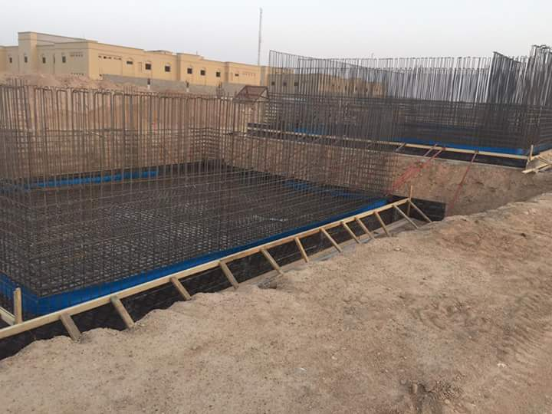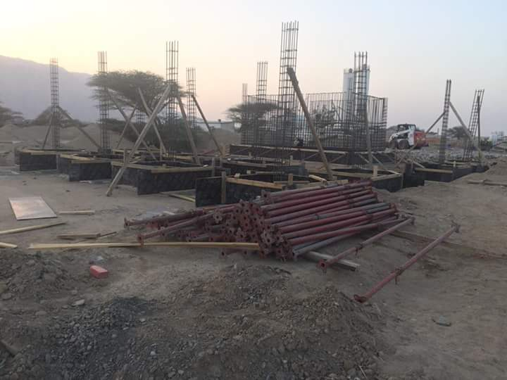

Al-Malik Al-Masiah Trading & Contracting L.L.C
Muscat Projects L.L.C (STP/ Royal Oman Police Khatwa)
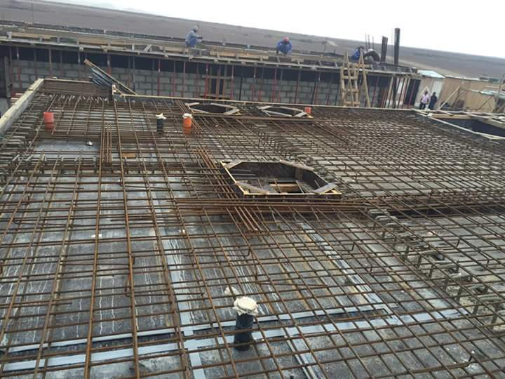
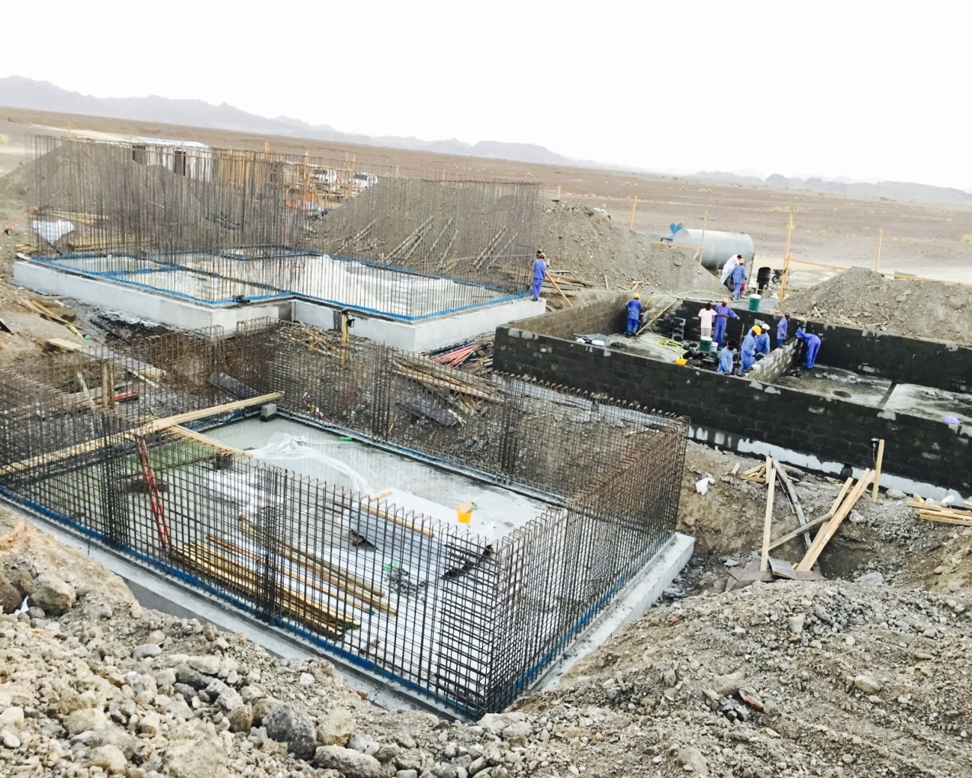
Al-Malik Al-Masiah Trading & Contracting L.L.C
Muscat Overseas L.L.C (20 Rooms School for Boys Khadra Buraimi )
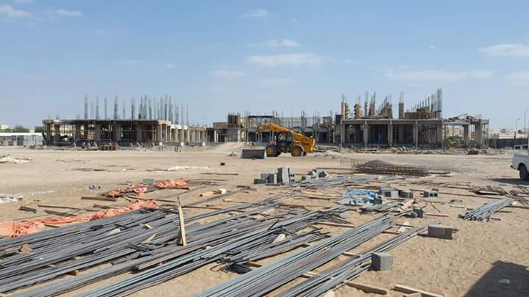

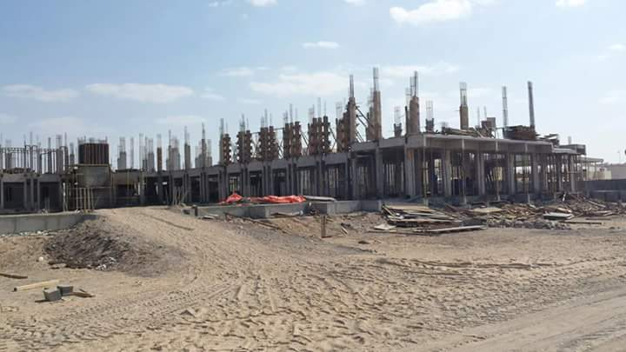
Al-Malik Al-Masiah Trading & Contracting L.L.C
Yas Medical Complex Buraimi (Yas Medical Complex)
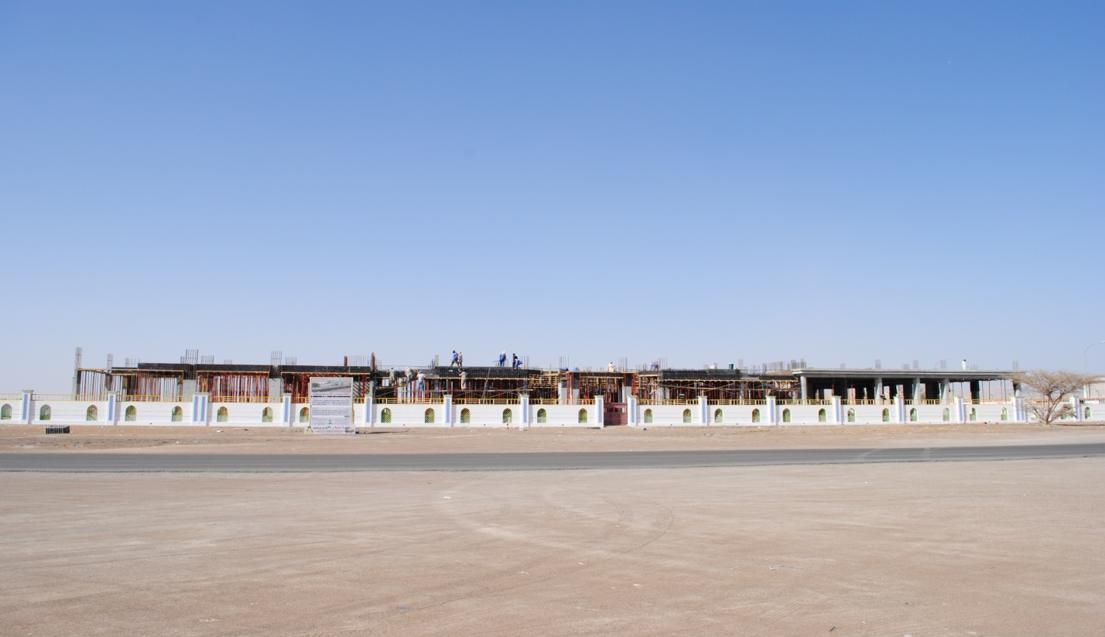

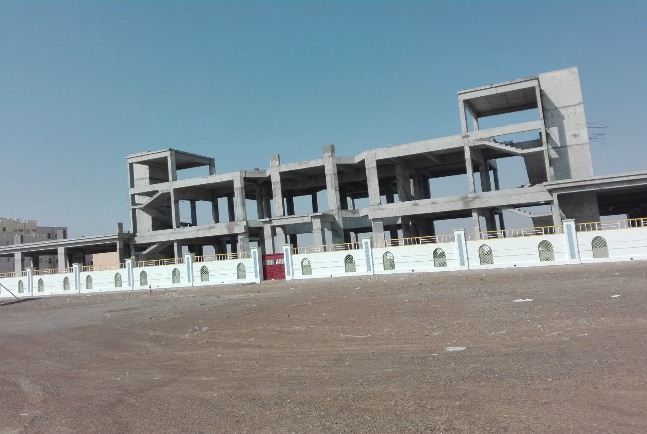
Al-Malik Al-Masiah Trading & Contracting L.L.C
Union Engineering Consultancy (Commercial Buildings)

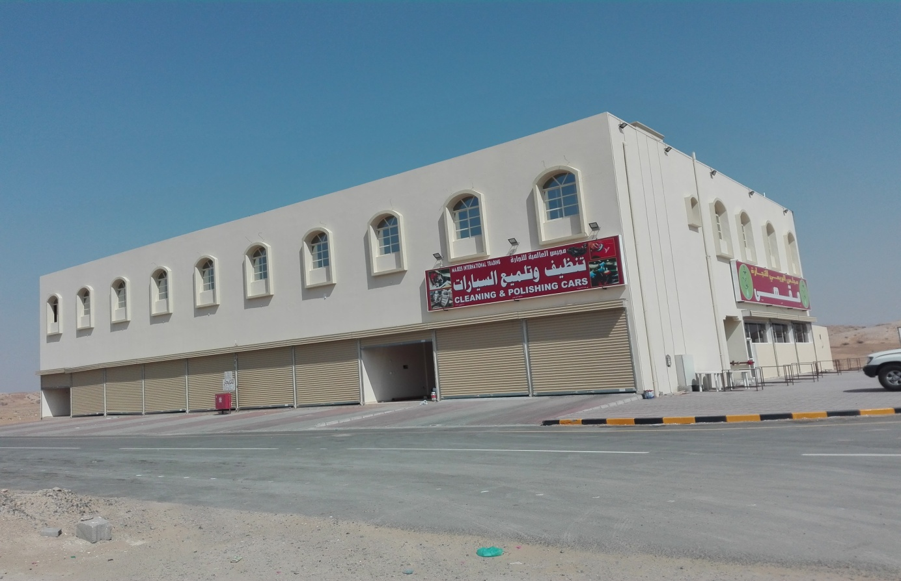

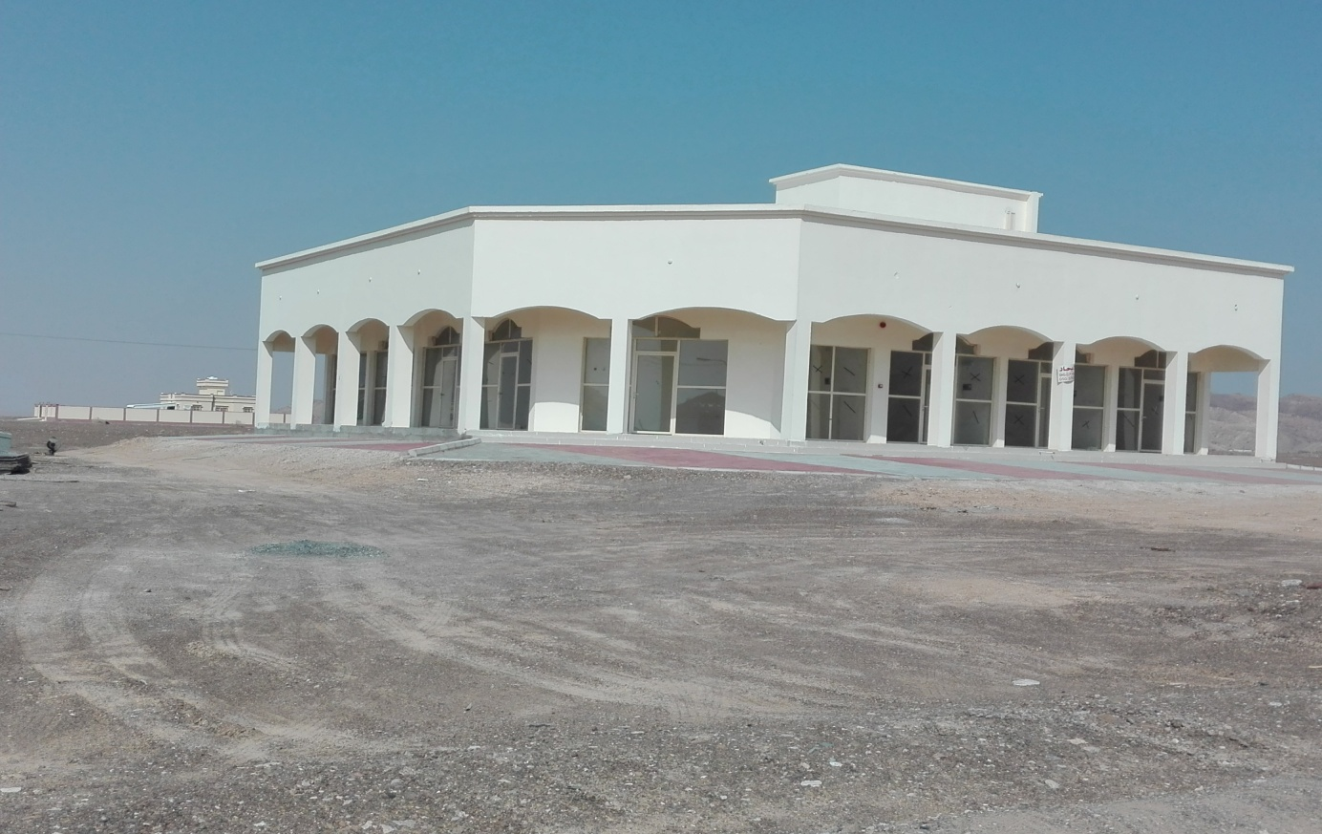
Al-Malik Al-Masiah Trading & Contracting L.L.C
Dawood Contracting (Construction of Vocational School Buraimi)
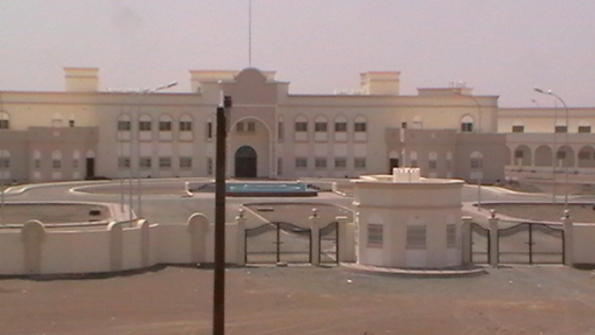

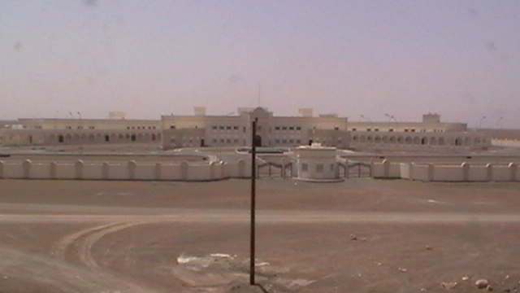
Al-Malik Al-Masiah Trading & Contracting L.L.C
Construction of MDF Factory & Sheds in Buraimi & Sohar (MIH Group (U.A.E)
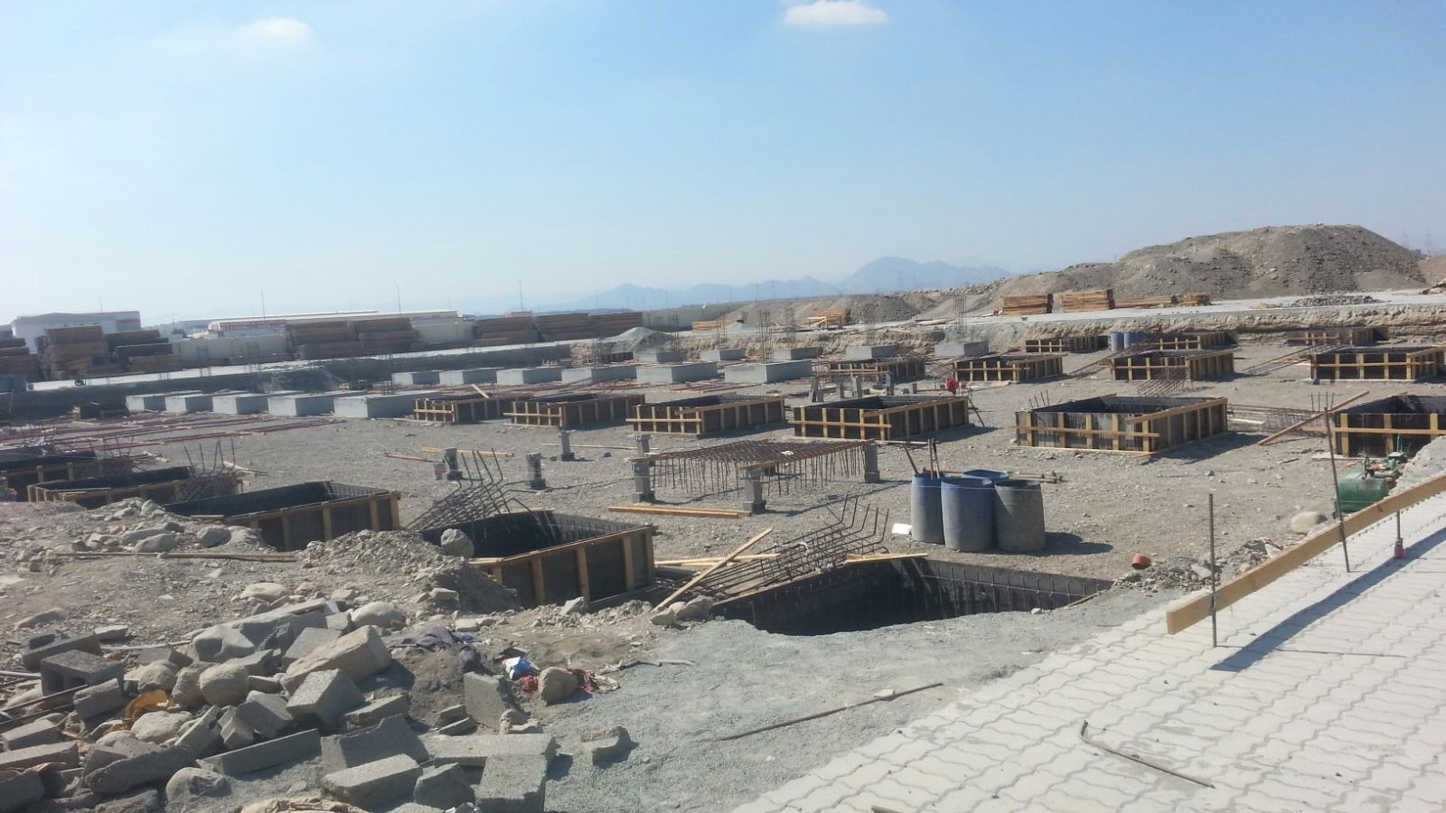

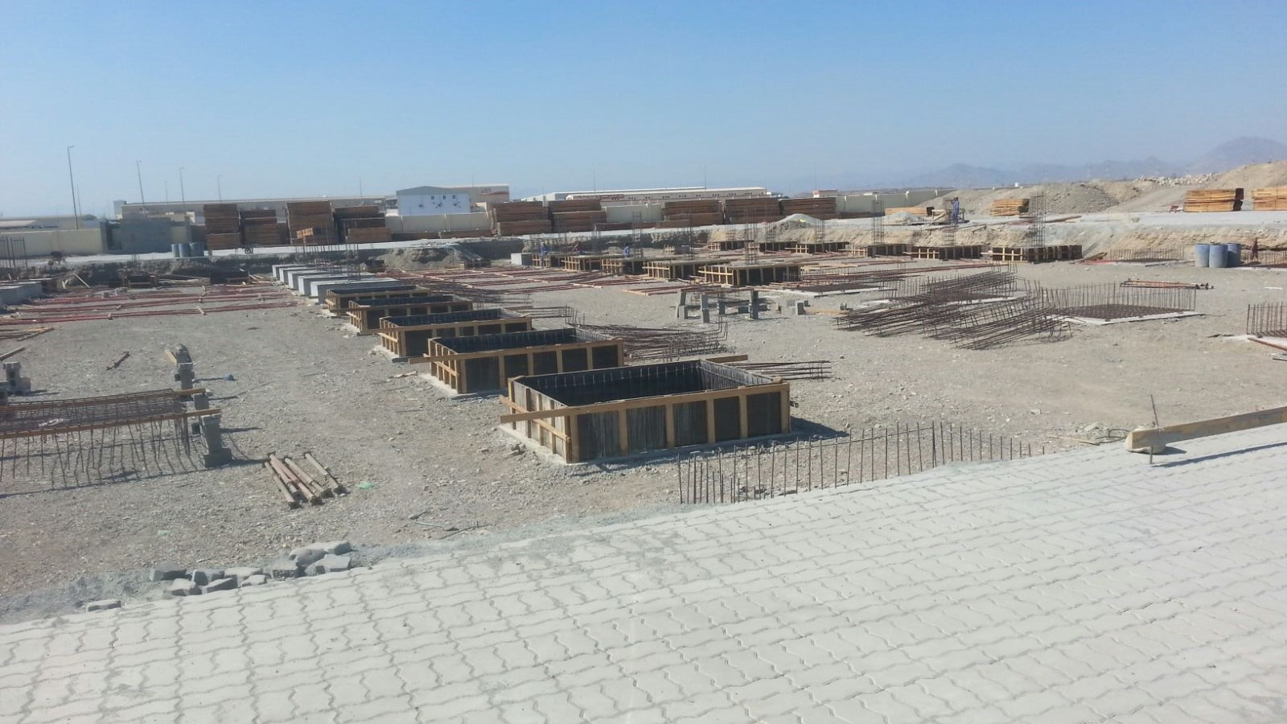
Al-Malik Al-Masiah Trading & Contracting L.L.C
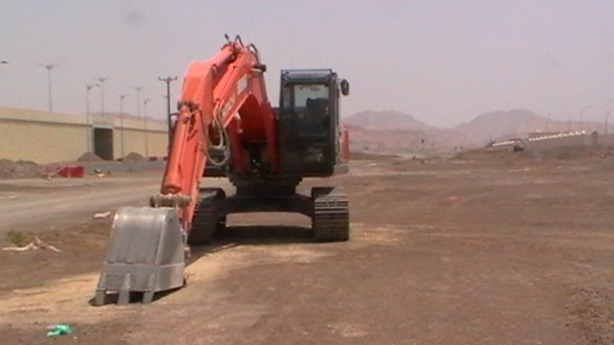
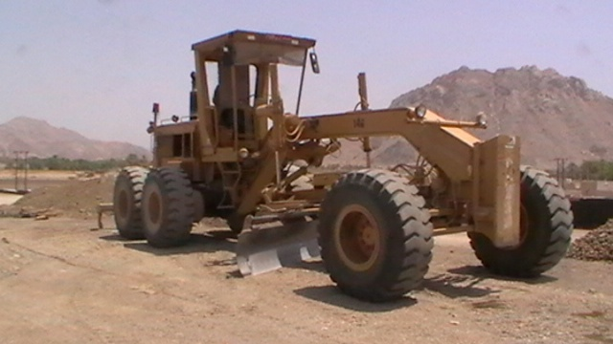
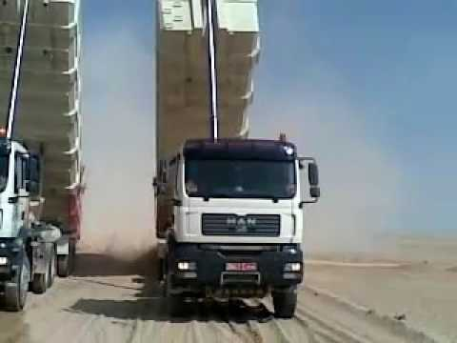
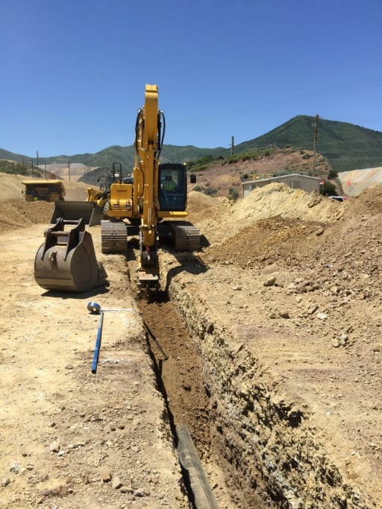
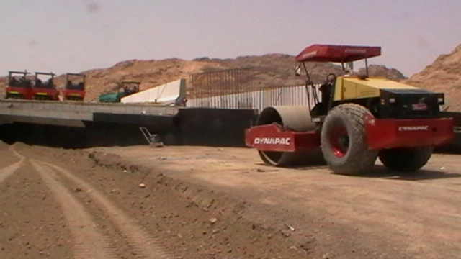
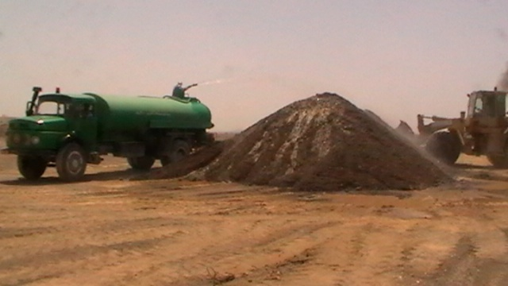
Gallery of Machinery

